Daniel S. Stepler
February 12, 1882 – May 19, 1957

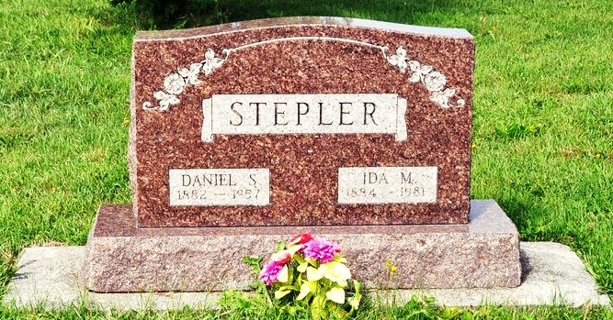
Daniel S. Stepler Dies Last Evening
Funeral Services Wednesday Morning
Daniel S. Stepler, 75, retired Kirkland Township farmer, died at 7:30 o'clock Sunday evening at a Richmond Hospital following an illness of several years. He was born in Adams County February 12, 1882, a son of John and Elizabeth Sifferly-Stepler, and was married to Ida Reichenbach February 12, 1914.
Mr. Stepler was a member of St. Luke's Evangelical and Reformed Church at Honduras.
Surviving in addition to his wife are two sons, Boyd D. Stepler of Sheboygan, Wis., and Freeman D. Stepler of Decatur, and five grandchildren. Four brothers and four sisters preceded him in death.
Funeral services will be conducted at 10:30 a.m. Wednesday at the Zwick Funeral Home, the Rev. Lewis Minsterman officiating. Burial will be in St. Luke's Church Cemetery. Friends may call at the funeral home after 7 o'clock this evening until time of the services.
Decatur Daily Democrat, Adams County, IN; May 20, 1957

