Aline (Sautbine) Bowman
December 11, 1833 – February 1, 1915

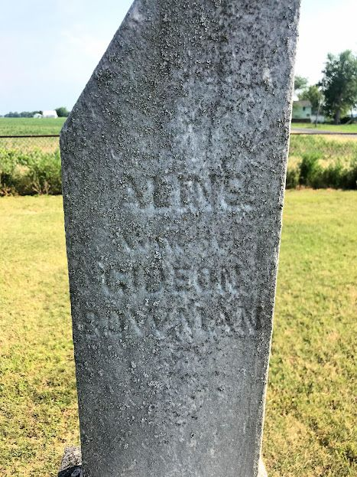
Photo by SMMR

MRS. GIDEON BOWMAN DIED AT AGE OF 91
AGED LADY PASSED AWAY ON MONDAY NIGHT NEAR HONDURAS
Mrs. Aline Bowman, aged 91, died Monday midnight, at her home south of Honduras, from infirmities of age. She was a daughter of Charles and Julia Sautbine, and was born December 11, 1833. Her husband, Gideon Bowman, preceded her in death, as did a daughter, Mrs. Augustine Durr.
Children surviving are Isaac Bowman and W. A. Bowman, of Adams County; Mrs. Eliza Davenport, wife of Dr. Davenport, and Loretta Rundell, of Craigville, and Miss Nettie Bowman, at home. A sister, Mrs. Julia Earl, lives in Minnesota. There are 22 grandchildren and 19 great grandchildren.
The funeral will be held Thursday at 1:30 at Honduras, in charge of Rev. Schroer.
Bluffton Chronicle, Wells County, Indiana
February 3, 1915
*****

Indiana, Death Certificates, 1899-2011

Name: Aline Bowman
[Aline Sanwine]
Gender: Female
Race: White
Age: 81y 1m 20d
Marital status: Widow
Birth Date: 11 Dec 1833
Birth Place: Ohio
Death Date: 1 Feb 1915
Death Place: French, Adams, Indiana, USA
Father: Chas Sautbine
Mother: Julia Brady
Informant: Mrs. E. Davenport, Craigville
Burial: Feb. 4, 1915 Zion

