David Crum
April 22, 1854 – January 24, 1929

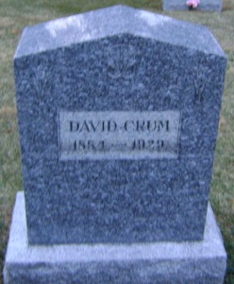
Photo by Bruce Sonner

DAVID CRUM IS CALLED BY DEATH
Aged Resident of Kirkland Township Dies Following Extended Illness

David Crum, 74, of Kirkland Township, died at his home at 10:30 o'clock last night, following an illness of more than a year. Death was said to have been due to kidney trouble and a complication of ailments. Mr. Crum was born in Ohio, April 22, 1854. He was a son of Daniel and Elizabeth Crum. When a young man, Mr. Crum came to Adams County with his parents and their family and has since resided in this county. Mr. Crum never married.
He is survived by two brothers, J. G. Crum and J. M. Crum both of Adams County. Two sisters and a brother preceded him in death.
Funeral services will be held Sunday afternoon at 2 o'clock at the Zion Church. Burial will be made in the church cemetery.

Decatur Daily Democrat, Adams County, Indiana
January 25, 1929

