Emma (Sovine) Fulk
February 27, 1849 – April 22, 1902

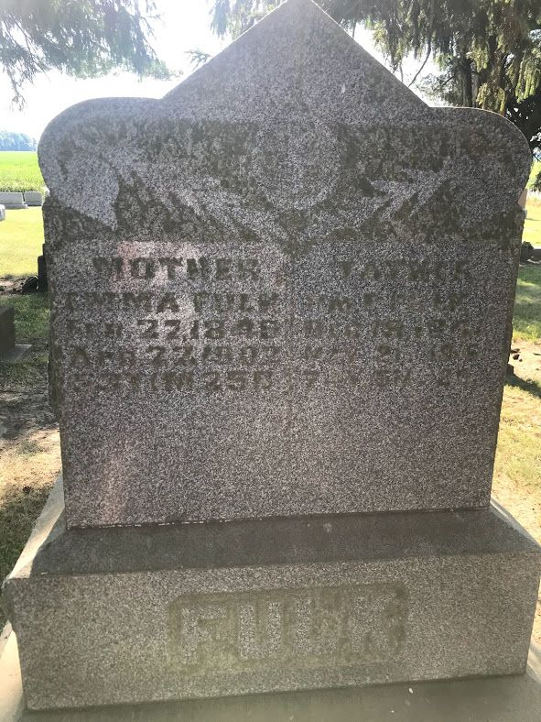
Photo by SMMR

Mrs. William Fulke [sic], mother of the ex-surveyor of Adams County, dropped dead yesterday at her home a mile east of Honduras. The funeral occurs at the house Friday at 9:30.

Bluffton Chronicle, Wells County, Indiana
April 23, 1902
*****
Mrs. William F. Fulk, one of the best known ladies of the county, and mother of ex-Surveyor W. E. Fulk, died very suddenly Tuesday evening about five o'clock from heart trouble. She had been in good health and the close of her useful life came without warning. While talking with a neighbor lady she suddenly became affected with paralysis of the heart and fell to the floor. Medical assistance was sent for and Dr. D. D. Clark of this city went out immediately but life had been extinct long before his arrival. It is believed she died instantly.
She resided with her son on the home farm in Kirkland Township, about nine miles southwest of the city. She was fifty-three years old and a woman of many good qualities. Three sons, William E., Lewis P., and John H., survive her. Funeral services will be held tomorrow.

Decatur Democrat, Adams County, Indiana
April 24, 1902

*****
Indiana, U.S., Death Certificates, 1899-2011
Name: Emma Fulk
[Emma Sovine]
Gender: Female
Race: White
Age: 53 years, 1 month, 25 days
Marital status: Married
Birth Date: abt 1849
Birth Place: Indiana
Death Date: 22 Apr 1902
Death Place: Kirkland, Adams, Indiana, USA
Father: Henry Sovine
Mother: Julia Emily?
Spouse: Wm E. Fulk
Informant: Wm. E. Fulk; Decatur, Indiana
Burial: April 25, 1902; Zion Cemetery

