Ruth F. (Crum) High
November 6, 1891 – January 26, 1971

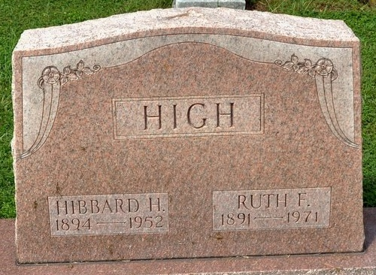
Photo by Deb Curry

Mrs. Ruth S. High is taken by Death

Mrs. Ruth S. High, 79, widow of Hibbard H. High, a lifelong resident of Adams County, was found dead Tuesday evening at her home on Decatur Route 4. She had been ill for several years and was believed to have died about 6 a.m. of a heart seizure.
Born in Adams County November 6, 1891, she was a daughter of Frank and Emma Ehle-Crum, and was married to Hibbard H. High March 8, 1916. Her husband preceded her in death May 5, 1952. Mrs. High was a member of the St. John's United Church of Christ at Vera Cruz.
Surviving are one son, Robert High of Decatur Route 4; one brother, Oscar B. Crum of Fort Wayne, and a granddaughter. Funeral rites will be held at 10:30 a.m. Friday at the Goodwin Funeral Home in Bluffton, with Rev. John Dulin officiating. Burial will be in Zion Cemetery. Friends may call at the funeral home after 7 p.m. today.

Decatur Daily Democrat, Adams County, Indiana
January 27, 1971

