John C. Myers
February 4, 1847 – October 18, 1927

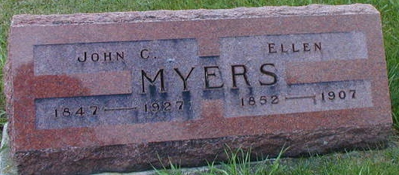
Photo by Alicia Kneuss

JOHN C. MYERS CALLED BY DEATH
Retired Adams County Farmer Dies At Home in Kirkland Township

John C. Myers, 80, retired Adams County farmer, died of heart trouble and hemorrhages at his home in Kirkland Township, at 4:45 o'clock Tuesday afternoon. Mr. Myers had been ill for two months.
John C. Myers was a son of George and Rhoda (Esther) Allshouse Myers and was born in West Moreland County, Pennsylvania, February 4, 1847. He had resided in Adams County for 48 years. He was married to Ellen Cline, December 19, 1871. Mrs. Myers died September 14, 1907.
Mr. Myers was a member of the Christian Union Church.
Four sons survive. They are L. E. Myers, of Fort Wayne; William A. Myers, of Bluffton; Frank P. Myers, of Monroe; and George Myers, of Decatur. The following brothers and sister survive, also: Aaron Myers, of New Augusta, Indiana; Israel Myers, of Jolietville, Indiana; Mrs. Peter (Martha) Baker, Ephraim Myers, George Myers, Seno Myers, all of Leechburg, Pa.; and Sabanah (Labanah) Myers, of Canton, Ohio.
Funeral services will be held at the Zion Church at 1:30 o'clock Friday afternoon, with the Rev. Jay Smith, officiating. Burial will be made in the Zion Cemetery, Adams County.

Decatur Daily Democrat, Adams County, Indiana
October 19, 1927

