William Spannuth
February 26, 1867 – November 29, 1945

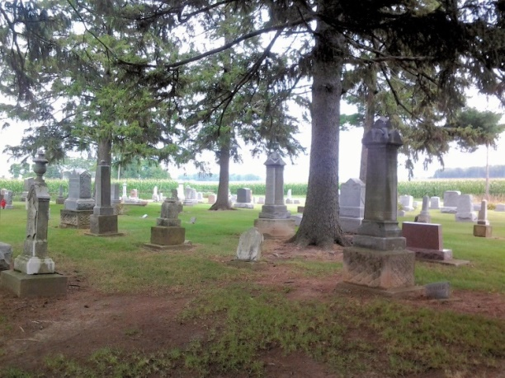
Photo by Tombstoner & Family

(Handwritten date: Monday, Dec. 3, 1945)

WM. SPANNUTH DIES AT COUNTY HOSPITAL

William Spannuth, 78, of Decatur route, died Thursday afternoon at the Adams county memorial hospital after a two months illness of complications. He was born in Ohio February 26, 1867, the son of Henry and Margaret Spannuth. He had never married and was the last surviving member of the family.

Adams County Historical Museum
1933-1953 Scrapbook, Image 010
*****

Indiana, U.S., Death Certificates, 1899-2011
Name: William Spannuth
Gender: Male
Race: White
Age: 78
Marital status: Single
Birth Date: 26 Feb 1867
Birth Place: Ohio
Death Date: 29 Nov 1945
Death Place: Decatur, Adams, Indiana, USA
Father: Henry L Spannuth
Mother: Margaret
Informant: H. M. Gillig; Decatur, Indiana
Burial: December 1, 1945; Honduras Cemetery; Decatur, Indiana

