Raymond L. Stoutenberry
April 7, 1892 – May 28, 1971

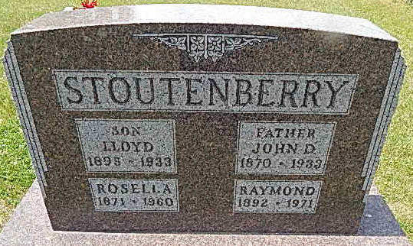
Photo by Alicia Kneuss

Raymond Stoutenberry is taken by Death

Raymond L. Stoutenberry, 79, a retired farmer, who resided at the Cooper Rest Home at Bluffton, died at 5:30 p.m. Friday at the home. He had been in serious condition the past three days. Mr. Stoutenberry was born on April 7, 1892, in Kirkland Township, the son of John and Rosella Sautbine-Stoutenberry, and was never married.
Surviving are two sisters, Mrs. Russell (Vera M.) Owens of Decatur, and Mrs. Anna Baumgartner of Vera Cruz; one brother, Marvin O. Stoutenberry of Route 3, and several nieces and nephews. One brother preceded him in death.
Funeral services will be conducted at 2 p.m. Monday at the Winteregg-Linn Funeral Home, with Rev. John E. Dulin officiating. Burial will be in the Zion Cemetery at Honduras. Friends may call at the Winteregg-Linn Funeral Home after 10 a.m. Sunday.

Decatur Daily Democrat, Adams County, Indiana
May 29, 1971
*****

Indiana, Death Certificates, 1899-2011
Name: Raymond L Stoutenberry
Gender: Male
Race: White
Age: 79
Marital Status: Married
Birth Date: 7 Apr 1892
Birth Place: Ind
Death Date: 28 May 1971
Death Place: Bluffton, Wells, Indiana, USA
Father: John Stoutenberry
Mother: Rosella Sautbine
Informant: Mrs. Russell Owens of Decatur, sister
Burial: May 31, 1971 Zion Cem.

