Rosella (Sautbine) Stoutenberry
July 25, 1871 – May 20, 1960

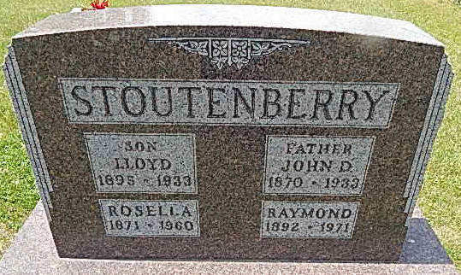
Photo by Alicia Kneuss

Mrs. Stoutenberry Dies This Morning

Mrs. Rosella Stoutenberry, 88, lifelong resident of Adams County, residing four and one-half miles southwest of Decatur, died at 4:40 a.m. today at the Adams County Memorial Hospital. She had been ill one year and hospitalized for two weeks.
She was born in Kirkland Township July 25, 1871, a daughter of Isaac and Lucinda Bolinger-Sautbine, and was married to John D. Stoutenberry in 1892. Her husband preceded her in death December 5, 1933. Mrs. Stoutenberry was a member of the Zion Christian Union Church.
Surviving are two sons, Raymond, at home, and Marvin, of Decatur route 3; two daughters, Mrs. Russell (Vera) Owens of Decatur, and Mrs. Dan (Anna) Baumgartner of Vera Cruz; three grandchildren; four great-grandchildren; two brothers, William Sautbine of Decatur, and Roy Sautbine of Decatur Route 4, and one sister, Mrs. Ada Hayberg of Nalker, Minn. Funeral services will be conducted at 2 p.m. Sunday at the Zwick Funeral Home and at 2:30 p.m. at the St. Luke's Evangelical and Reformed Church, the Rev. L. A. Minsterman officiating. Burial will be in the Zion Cemetery at Honduras. Friends may call at the funeral home after 7 p. m. today until time of the services.

Decatur Daily Democrat, Adams County, Indiana
May 20, 1960
*****

Indiana, Death Certificates, 1899-2011
Name: RosellaStoutenberry
[Rosella Sautbine]
Gender: Female
Race: White
Age: 88
Marital Status: Widowed
Birth Date: 25 Jul 1871
Birth Place: Indiana
Death Date: 20 May 1960
Death Place: Decatur, Adams,Indiana, USA
Father: Isaac Sautbine
Mother: Lucinda Bolinger
Informant: Marvin Stoutenberry, son
Burial May 22, 1960 Zion Cem.

