William F. Zaugg
March 12, 1904 – May 8, 1978

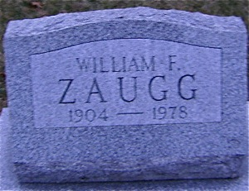
Photo by Bruce Sonner

William F. Zaugg
William F. Zaugg, 74, route 6, Decatur, died suddenly at his home Monday. Mr. Zaugg's body was discovered at 9:30 a.m. Monday.
A member of St. Luke's United Church of Christ, Mr. Zaugg was a retired farmer.
He was born March 12, 1904 in Adams County to Phillip and Margaret Baumann-Zaugg, and never married.
Survivors include a sister, Mrs. Frank (Emma) Hanni, Quincy, Michigan; a brother, Ervin Zaugg, route 1, Ossian; and several nieces and nephews. One sister is deceased.
Funeral services will be held at 10 a.m. Thursday in Winteregg-Linn & Haggard Funeral Home, Rev. Kent Ulery in charge, and burial will be in Zion Cemetery. Friends may call at the funeral home after 2 p.m. Wednesday.
Preferred memorials are to the church.
Decatur Daily Democrat Adams County, Indiana
Tuesday, May 9, 1978
Page 2, Column 3

