Barbara J. (Birch) Burnikel
February 7, 1951 – October 14, 2007

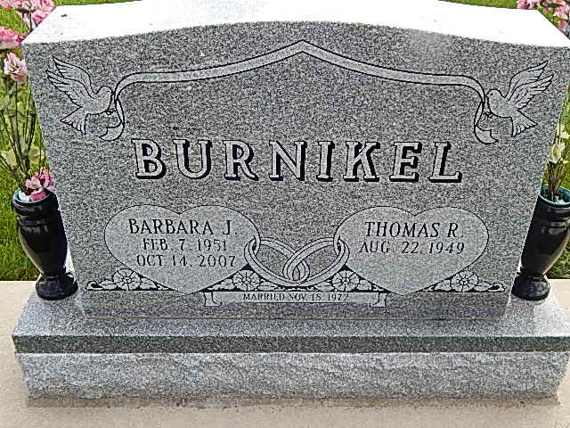
Photo by Alicia Kneuss
Barbara J. (Birch) Burnikel, 56 of Evansville, Indiana formerly of Adams County died on October 14, 2007 at St Mary's Hospital in Evansville, Indiana. Barbara was the daughter of Harvey E. Birch & Irene L. Birch both of Monroe. She was born in Adams County on February 7, 1951. She married Tom Burnikel on November 18, 1973. He survives in Evansville.
Other survivors include a son Cory Burnikel of Indianapolis, a daughter Angie Burnikel of Charlotte, N.C., 2 brothers Allen Birch of Monroe and Todd Birch of Hamilton; a grandchild Haley Burnikel of Columbus, Ohio.
Barbara was a registered nurse for 25 years. She worked for Welborn Hospital and Visiting Nurses Association in Evansville.
Calling hours are 4-8 pm Wednesday, October 17, 2007 at Haggard & Sefton Funeral Home. Funeral service will be held at 2:00 pm Thursday, Oct. 18, 2007 also at the funeral home. Rev. Troy Green will be officiating and burial is in Spring Hill-Backesto in rural Berne.
Memorials are to Vanderburgh Humane Society.
Haggard-Sefton & Hirschy Funeral Home, Adams County, Indiana
October 15, 2007

