Guy R. Calderwood
March 31, 1891 – May 21, 1912
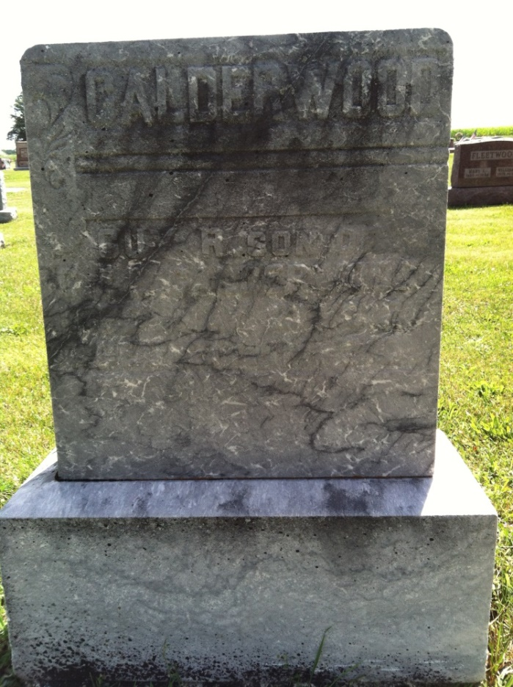
Photo by Barbara Baker Anderson

Doctors Schank and Reusser, of Berne and Parish and Rayl, of Monroe, held a post mortem examination over the corpse of Guy Calderwood last Tuesday. He was buried at Spring Hill Thursday at 2 o'clock.
Berne Witness, Adams County, Indiana
May 24, 1912
*****

Guy R. Calderwood was born at Salem, Adams County, Ind., March 31, 1891 and died May 21, 1912, aged 21 years, 1 month and 21 days. He lived with his grandmother, Maria Yant, since he was 7 years old except two or three winters while he was attending school. He suffered greatly the last six weeks and wished many times he could die. A few hours before his death he called his grandmother and putting his arms around her neck; he kissed her and said, "Grandma, I am going home."
The bereaved are his father, one brother and three sisters. His mother, one brother, and two sisters preceded him in death.
He was buried at Spring Hill at 2 o'clock Thursday. Funeral services were conducted by Rev. Kuhn, of Willshire.

Berne Witness, Adams County, Indiana
Tuesday, May 28, 1912
*****
The funeral of Guy Calderwood, son of George Calderwood, and grandson of Mrs. Maria Yant was held at the Spring Hill church last Thursday afternoon, and conducted by Rev. Kohn of Willshire.
Guy, son of George Calderwood, died Tuesday morning at the home of Mrs. John Yant.

Berne Witness, Adams County, Indiana
Friday, May 31, 1912

