Roselyn Pauline (Huser) Johnson-Habegger
March 9, 1931 – March 26, 2018

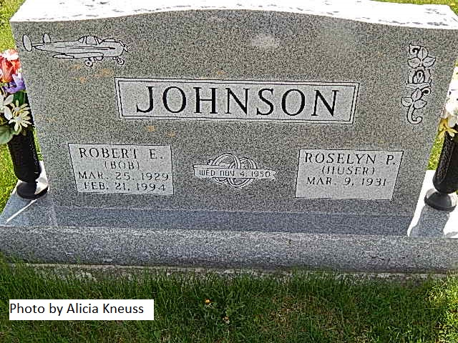

Roselyn Pauline Johnson-Habegger, 87, of Berne, Indiana was called to her heavenly home early Monday morning, March 26, 2018.
She was born on March 9, 1931 in Adams County to the late Amos Huser and the late Susie (Clark) Huser. She graduated from Jefferson High School in 1949. On November 4, 1950 she married Robert E. Johnson and he preceded her in death on February 21, 1994. She then married C. Earl Habegger on November 30, 1996 and he died on January 3, 2008.
Rose was a charter member of the Springhill Missionary Church. She was an active member, having served on various committees & was active in the Women’s Missionary Society. Rose was also a member of the Swiss Red Hatters and the Merrier Monday’s Home Economics Club. Rose worked as a branch manager for the First Bank of Berne and served there for 23 ½ years.
She loved to watch Indiana University Basketball and was an avid fan of her grandchildren and great-grandchildren’s sporting events & other various activities.
Surviving are two sons, Walter Johnson & Ronald (Kay) Johnson both of Berne; a daughter, Connie (John) Hammond of Decatur; step-daughter, Teri Coolman of Fort Wayne; step-son, Scott (Karen) Habegger of Milwaukee, WI; step-sister, Yovvone Neuenschwander of OR; ten grandchildren; 21 great-grandchildren; six step-grandchildren; & six step-great-grandchildren.
Rose was the last surviving member of her family. She was preceded in death by her step-mother, Helen (Reuesser) Huser; sisters, Helen Huser, Velma Reef, & Esther & Edith; brothers, Alton J. Edison “Bud”, Raymond, Junior A., & an infant brother; step-sisters, Jeanette Head; step-daughter, Luann Martin; & great-grandson, Henry Hammond.
A funeral service will be held at 10:30 a.m. Friday, March 30, 2018 at Spring Hill Church with Pastor Bill Hull officiating. Interment will follow at Springhill (Backesto) Cemetery. Family & friends will be received from 2 to 8 p.m. Thursday, March 29, 2018 at Yager Kirchhofer Funeral Home in Berne and one hour prior to the service at the church on Friday.
Preferred memorials are to Springhill Church of ACCF Angel Cancer Fund.

Yager-Kirchhofer Funeral Home online obit (accessed 3/27/2018)

