Joel C. Mazelin
August 10, 1910 – August 28, 1911

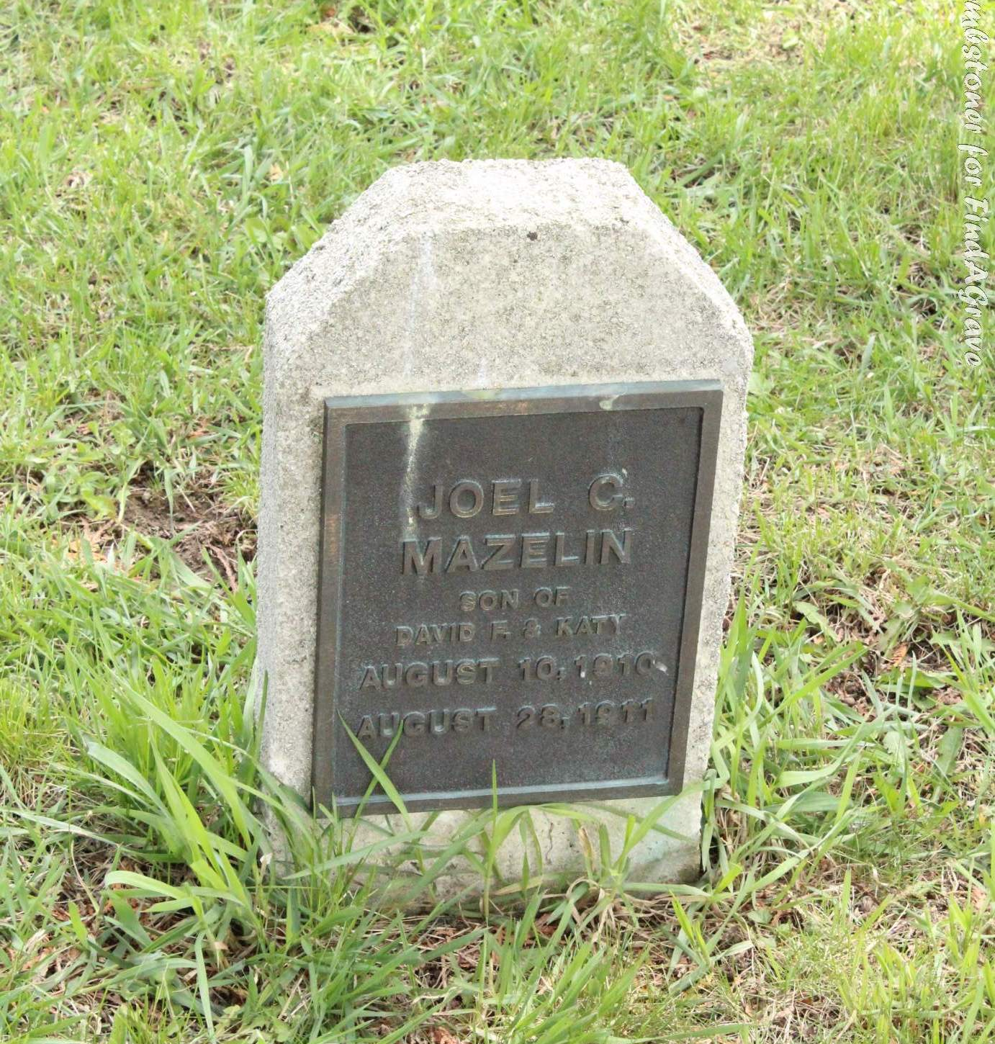
Photo by Tombstoner & Family
The youngest son of Mr. and Mrs. David F. Mazelin, living four miles northwest of town, died early Monday morning of spasms. It was one year and eighteen days old and had not enjoyed good health for some time. The funeral was held Tuesday afternoon.
Berne Witness, Adams County, Indiana; Friday, Sept. 1, 1911
Contributed by Karin King

