Adella P. (Habegger) Graber
March 10, 1900 – December 1, 1951
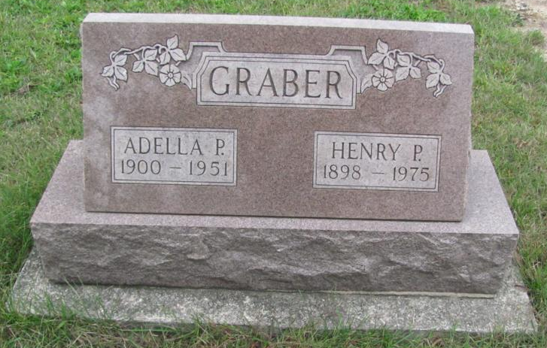
Photo by Jenna Langston

(Handwritten date: Monday, Dec. 3, 1951)

RITES TODAY FOR WIFE OF HENRY P. GRABER
Monroe Township Woman Dies Early Saturday Morning

Funeral services were held at 2:00 p.m. today at the Evangelical Mennonite church west of Berne for Mrs. Adella Habegger Graber, 51, wife of Henry P. Graber of Monroe township.
Mrs. Graber died at her home 3 1/2 miles north and a mile west of Berne at 2:20 a.m. Saturday. The Rev. E. G. Steiner, pastor of the church, officiated, and burial was in the Mazelin cemetery two miles north and one-half mile west of Berne.
Mrs. Graber died from carcinoma following a long illness. She had been bedfast for four weeks but had ailed for many months previously.
Mrs. Graber was a native and lifelong resident of Monroe township. She was born north of Berne on March 10, 1900, the daughter of Peter P. and Rosina Schwartz Habegger. She was married to Mr. Graber on Christmas day in 1925 [sic - 1921].
Surviving are the husband; three daughters, Mrs. Elmer A. (Evelyn) Rich, Monroe; Mrs. Marvin (Eileen) Sprunger, Berne; Delores May Graber, at home; a son, Donald Dale Graber, at home; three grandchildren; four sisters, Mrs. Dan P. Steury and Mrs. Chris P. Steury, Berne route 1; Mrs. David P. Steury, Berne, and Mrs. Jacob C. Mazelin, Ethridge, Tenn., and a brother, Enoch P. Habegger, also of Ethridge.
Two brothers, Joseph and Caleb Habegger, and two sisters, Mrs. Rachel Schrock and Mrs. Rosina Inniger, preceded in death. Mrs. Graber and Mrs. Inniger were twin sisters. Mrs. Inniger died in August of 1939.
Mrs. Graber was a member of the Amish Christian church north of Berne.

*****
(Handwritten date: Sunday, December 2, 1951)

GRABER

BERNE - Mrs. Adella Graber, 51, critically ill one month with carcinoma, died at 2:20 a.m. yesterday at her home three and one-half miles north and one mile west of Berne. She was a native and lifelong resident of Monroe Township. Surviving are the husband, Henry; three daughters, Mrs. Elmer A. Rich, Monroe; Mrs. Marvin D. Sprunger, Berne and Miss Delores Graber, at home; one son, Donald, also at home; three grandchildren; a brother, Enoch P. Habegger, Ethridge, Tenn., and four sisters, Mrs. Dan Steury and Mrs. Chris P. Steury, both near Berne; Mrs. David P. Stuery, Berne and Mrs. Jacob C. Mazelin, also of Ethridge. Mrs. Graber was a member of the Apostolic Christian Church. Services will be conducted at 2 p.m. Monday in the Evangelical Mennonite Church west of Berne with the Rev. E. G. Steiner, pastor, officiating. Burial will be in the Mazelin Cemetery, northwest of Berne. Friends may call here at the Yager Funeral Home. (Handwritten: "A member of Amish Christian Church")

Adams County, Indiana Historical Society
1933-1953 Scrapbook - Image 62
Transcribed by Karin King

