Andrew Theodore Brewster
February 16, 1901 – May 15, 1940

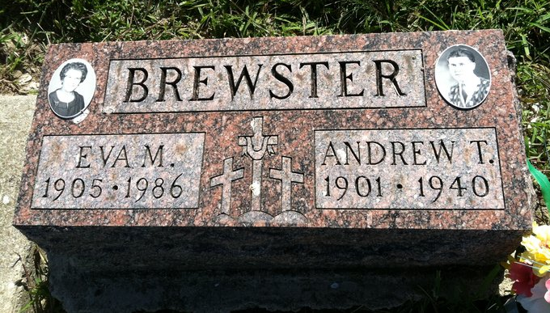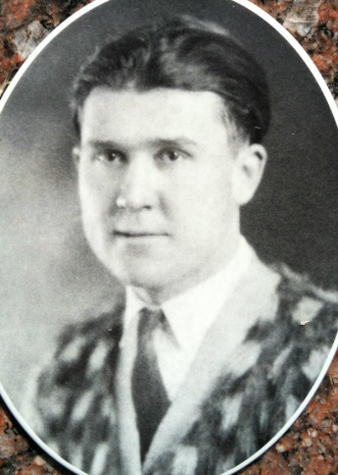
Photos by Barbara Baker Anderson

ANDY BREWSTER DIES SUDDENLY
Well Known Monroe Man Dies Of Heart Attack Last Night

Andrew T. Brewster, 39, died suddenly last night at 10:15 o'clock at his home in Monroe. Death was attributed to a heart attack. He had returned home from his work on a WPA crew last evening becoming ill shortly after. His death followed in a few hours.
The deceased was born in Jefferson Township February 16, 1901, the son of Winfield Scott and Jane Seabright Brewster. He was formerly employed at the Decatur Casting Company for 15 years and for seven years resided in this city.
Surviving besides the widow, are a daughter, Joyce; three brothers, Charles and John of Geneva, and Ed of Fort Recovery, Ohio, and a sister, Mrs. Charles Liby of Craigville.
Funeral services will be held Friday afternoon at 1 o'clock at the home (CDT) and 1:30 o'clock at the Monroe Methodist Church, with Rev. R. F. Hart officiating. Burial will be in the Ray Cemetery.
The body was taken to the Zwick Funeral Home in this city, but the time when it will be returned to the residence has not been stated.

Decatur Daily Democrat, Adams County, Indiana; Wednesday, May 15, 1940
*****
BREWSTER
Decatur, May 15 – Andrew T. Brewster, 39, died late Tuesday night at his home in Monroe a few hours after suffering a heart attack. He was employed at the Decatur Casting Company here for 15 years, moving to Monroe seven years ago.
Surviving besides the widow are a daughter, Joyce, at home; three brothers, Charles and John of Geneva and Ed of Ft. Recovery, O.; and one sister, Mrs. Charles Liby of Craigville.
Funeral services will be held at 1 pm (CDT) Friday at the home and at 1:30 o’clock at the Monroe Methodist Church. Burial will be in the Ray Cemetery near Monroe.
Journal-Gazette, Fort Wayne, IN; May 16, 1940
Contributed by Jim Cox
*****
(Handwritten date: Wednesday, May 15, 1940)
MONROE MAN DIES SUDDENLY
Funeral For Andrew Brewster, 39, is Friday P.M.

Andrew Brewster, 39, died suddenly at his home in Monroe about 8:30 this morning from apoplexy. He had not been ill and his death was very unexpected. He had reported for work on a WPA project but returned home when inclement weather prevented work.
The decedent was a cousin of the Brewsters residing in this community and was the son of Winfield and Jane Seabright Brewster. He was born in this county February 16, 1901. His parents preceded.
His marriage to Eva Garwood took place August 20, 1925. One (cut off)

Adams County, Indiana Historical Society
1940 Scrapbook - Image 181
Transcribed by Karin King
*****
BREWSTER
Decatur, May 16 – Funeral services will be held at 2 pm (CDT) Friday at the home for Andrew T. Brewster, who died suddenly Wednesday morning and at 2:30 o’clock at the Monroe Methodist Church. Services are one hour later than previously announced.
Burial will be in the Ray Cemetery near Monroe.
Journal-Gazette, Fort Wayne, IN; May 17, 1940
Contributed by Jim Cox

