Doris Jean (Gaiser) Burkhead
September 28, 1924 – November 9, 2003
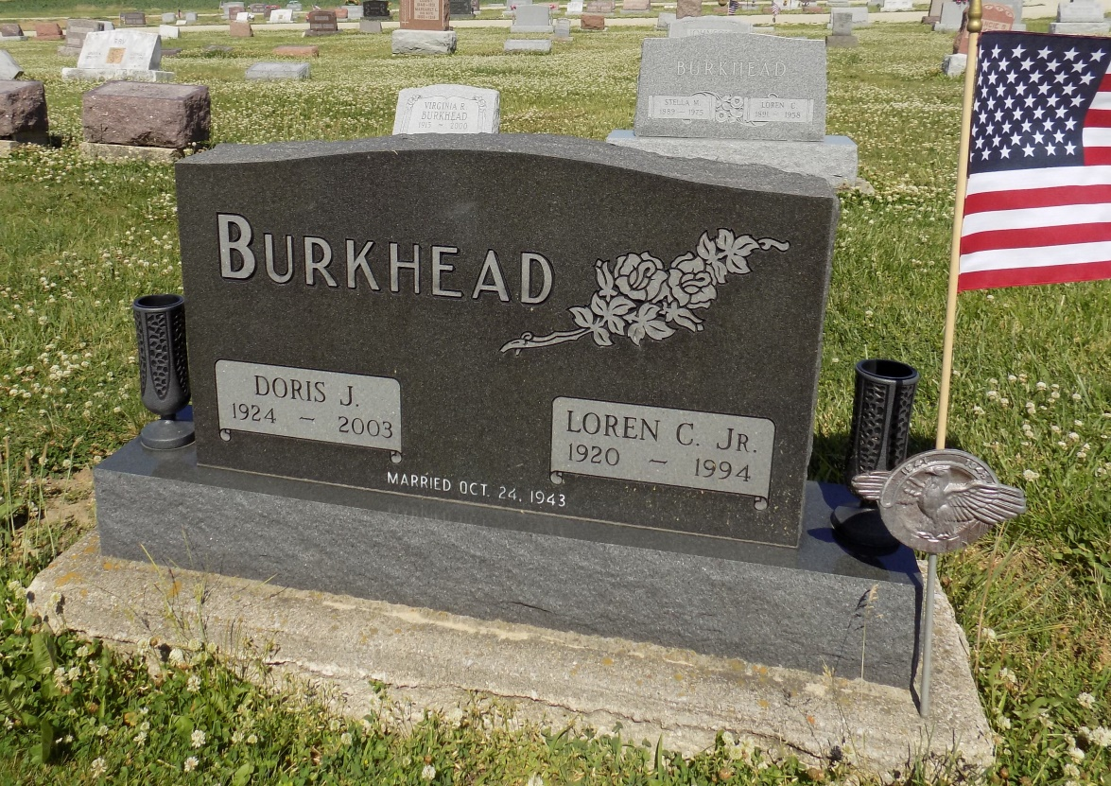
Photo by Margie Roop Pearce

DORIS J. BURKHEAD, 79, of Monroe, died Sunday, Nov. 9, 2003, 4:45 p.m., at Adams County Memorial Hospital, Decatur. Born Sept. 28, 1924, in Huntington County, she was the daughter of Oka M. and Stella (Lockwood) Gaiser. She was the Monroe Clerk/Treasurer for 24 years and retired Middle School Secretary for 21 years at Adams Central Middle School. She was a member of Monroe United Methodist Church, the United Methodist Women and the Builders Sunday School Class. Surviving are a daughter Mrs. Gary (Lisa) Cottingham of Indianapolis; two brothers, Leon Gaiser of Bluffton and Noel Gaiser of Bradford, Vt.; two sisters, Mrs. Robert (Crystal) Lee of Tucson, Ariz., Mrs. Paul (Marilyn) Miller of San Clemente, Calif.; two grandchildren, Lauren and Grant Cottingham. She was preceded in death by her husband, Loren C. Burkhead, who died Dec. 26, 1994, and a sister, Dorothy Beitleshees. Funeral service is 11 a.m. Friday, with viewing one hour prior, at Monroe United Methodist Church, with the Revs. Phil Lutz and Don Wilks officiating. Visitation is from 4 to 8 p.m. Thursday at Haggard & Sefton Funeral Home, Decatur. Burial at Ray Cemetery. Memorials to Monroe United Methodist Church. To light a candle click on www.haggardandsefton.com
News-Sentinel, The (Fort Wayne, IN) - Wednesday, November 12, 2003
Contributed by Jane Edson

