Larry H. Butler, Sr.
September 14, 1941 – April 9, 2014
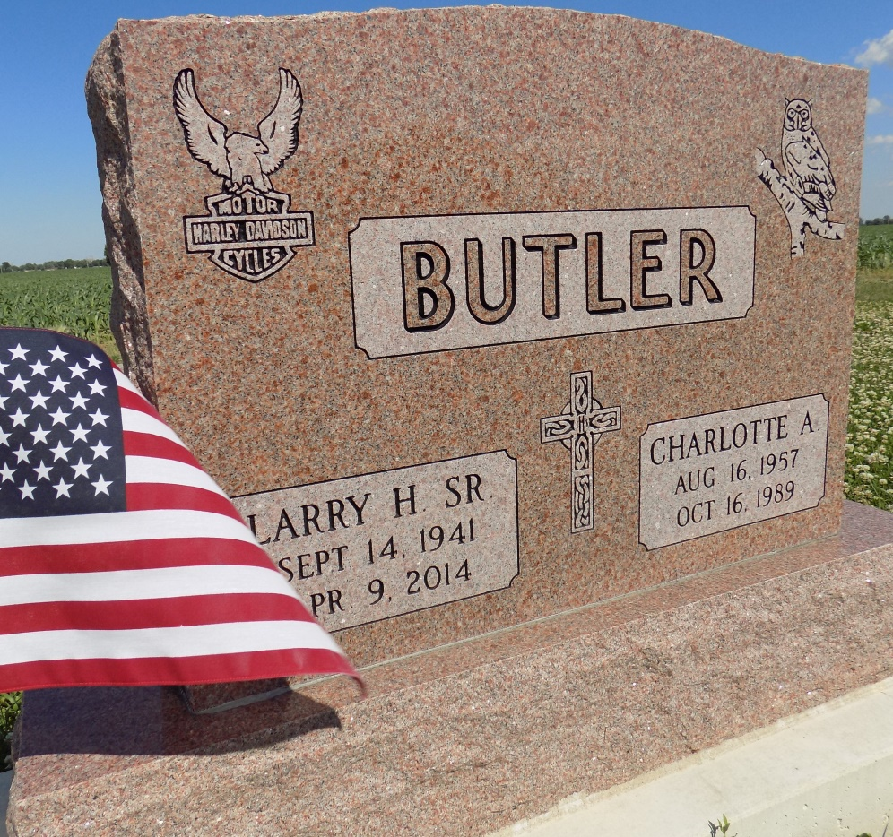
Photo by Margie Roop Pearce

Larry H. Butler Sr., 72, of Decatur, IN, passed away on Wednesday, April 09, 2014 at his residence. He was born on September 14, 1941 in Allen County, IN to the late Robert B. and Betty M. (Fair) Butler. He worked for Waste Management for 10 years and was also a truck driver for Don Ray Drive Away for 25 years. Larry served his country in U.S. Army in the 54th Infantry; he was stationed in Korea. He had a lifetime membership in the V.F.W. He is survived by 3 sons Larry (Betzi) Butler Jr. and John (Amy) Butler both of Decatur, and Dusty (Christina) Butler of Ft. Wayne; 2 daughters Terri Roe of Pittsburgh, PA and Angela Reed of Ft. Wayne; a sister Mrs. Russell (Bobbie Lou) Conrad of Middleburg, FL; 6 grandchildren. He was also preceded in death by his wife Charlotte Ann (Flynn) Butler. Per Larry’s request NO visitation or funeral will be held. A Graveside Service will be held at 10:00 a.m. on Saturday, April 19, 2014 at Ray Cemetery with Military Graveside Rites conducted by the American Legion Post 43. Memorials may be made to the American Legion Post 43. Arrangements by Haggard-Sefton & Hirschy Funeral Home.
Haggard-Sefton & Hirschy Funeral Home online obit (accessed 12/28/2014)

