Mary Maxine (Hilton) Dull
June 9, 1922 – July 2, 1999
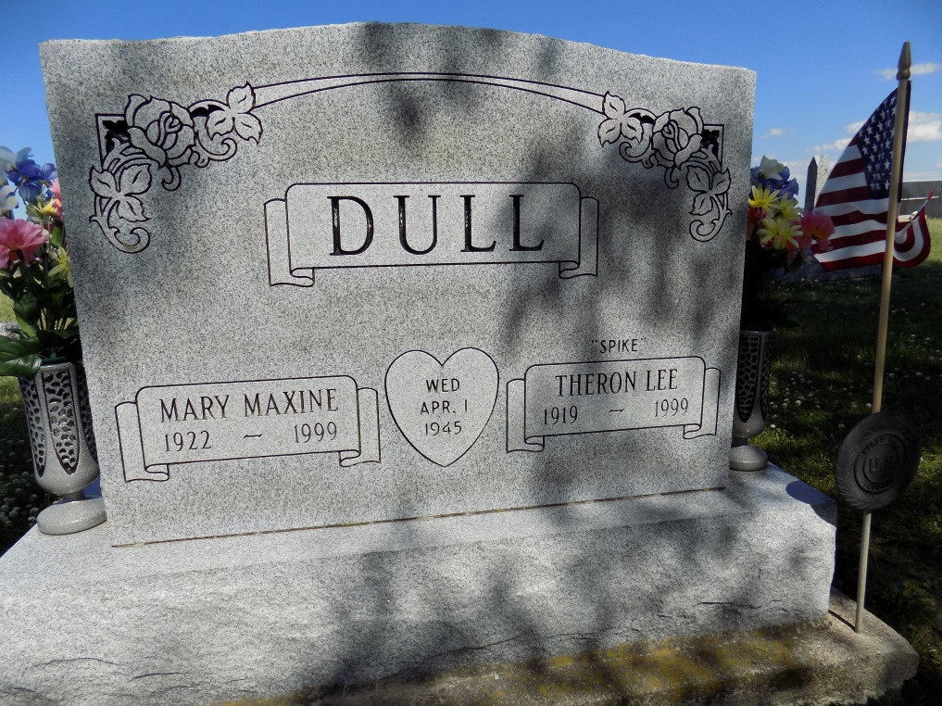
Photo by Margie Roop Pearce

Decatur Daily Democrat, Adams Co, IN; Saturday, July 3, 1999

Mary Maxine Dull, 77, 700 block Mondor Street, died at 1:06 a.m. Friday in Parkview Memorial Hospital, Fort Wayne. She was born on June 9, 1922 in Adams County to A. N. Peck Hilton and Esther L. Sovine. She married Theron L. Dull on April 1, 1945 (Easter Sunday), he died March 1 this year. Mrs. Dull is survived by a daughter, Mrs. Jerry (Mary Lee) Beitler, New Haven. She was preceded in death by a sister, Laura Alice Hilton. Mrs. Dull was a member of St. Mark's United Methodist Church and was a past president of the VFW Auxiliary, American Legion Auxiliary, and was past Pocahontas of Majella Counsil (sic) 72 Pocahontas Lodge, Decatur. She formerly worked for General Electric and was retired from CTS Berne. Funeral services are at 10 a.m. Tuesday at Haggard & Sefton Funeral Home, with burial to take place in Ray Cemetery, Monroe. Visiting hours are noon to 3 p.m. and 4 to 6 p.m. Monday at Haggard & Sefton Funeral Home. Memorials are to St. Mark's United Methodist Church or Parkview Cancer Center.

*****
News-Sentinel, The (Fort Wayne, IN) - July 3, 1999

Mary Maxine Dull Decatur - 1922-1999 Mary Maxine Dull, 77, of Decatur, past president of the VFW Auxiliary, died Friday, July 2, 1999, at Parkview Hospital. The Adams County native was retired from CTS in Berne, had worked for General Electric, was a member of St. Mark's United Methodist Church, American Legion Auxiliary and Past Pocahontas of Majella Council 72 Pocahontas Lodge. Surviving is a daughter, Mary L. Beitler of New Haven. She was preceded in death by her husband, Theron L., in March, and a sister. Services are 10 a.m. Tuesday at Haggard & Sefton Funeral Home, Decatur, with calling from noon to 3 and 4 to 6 p.m. Monday. Burial will be in Ray Cemetery, Monroe. Memorials are to the church or Parkview Cancer Center. Information provided by Haggard and Sefton Funeral Home, Decatur, 1-219-724-7167.

*****
Journal Gazette, The (Fort Wayne, IN) - July 4, 1999

MARY MAXINE DULL, 77, died Friday at Parkview Hospital, Fort Wayne. Born in Adams County, she had worked for General Electric Co. and retired from CTS in Berne. She was a past president of the V.F.W. Auxiliary and past Pocahontas of Majella Council 72 of the Pocahontas Lodge. Her husband, Theron L., died in March. Surviving is a daughter, Mary Lee Beitler of New Haven. Services at 10 a.m. Tuesday at Haggard & Sefton Funeral Home, Decatur, with calling from noon to 3 p.m. and 4 to 6 p.m. Monday. Burial in Ray Cemetery, Monroe. Memorials to St. Mark's United Methodist Church, Decatur, or Parkview Cancer Center, Fort Wayne.

