Bernice B. (Presdorf) Engle
October 4, 1918 – September 2, 2005

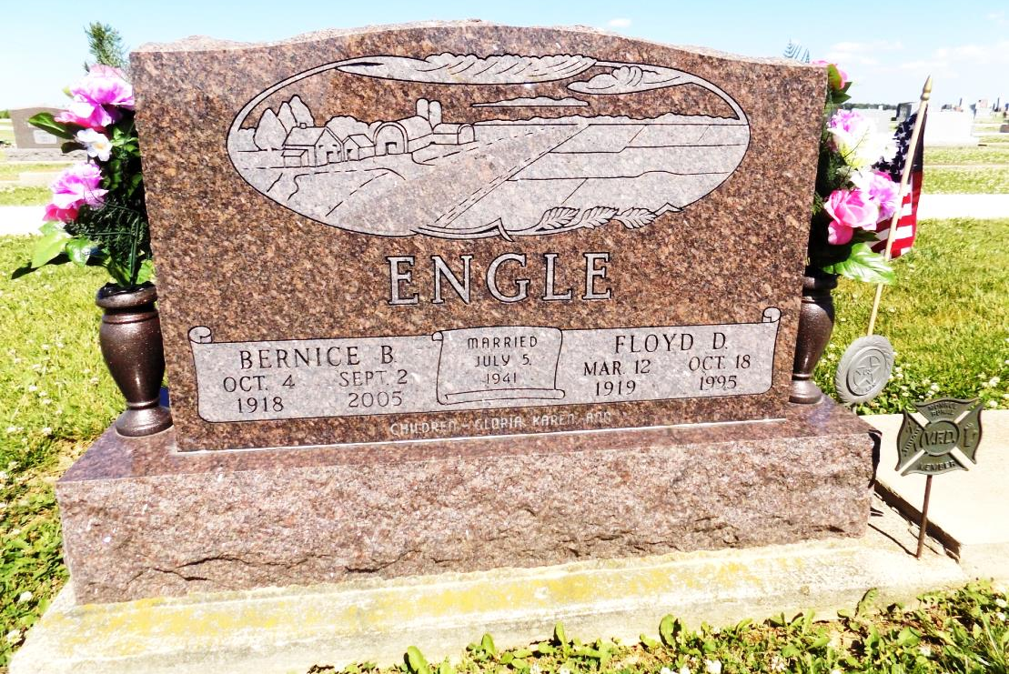
Photo by Margie Roop Pearce
Obits from Jane Edson

BERNICE B. ENGLE, 86, of Berne, died Friday, Sept. 2, 2005, 1:05 a.m., at Swiss Village. She was a homemaker. Surviving are three daughters, Gloria (David) Sommer and Karen (Max) Beer, both of Berne and Ann (Steve) Sprunger of Crown Point, Ind.; one brother, Robert Presdorf of LaGrange; 11 grandchildren and 11 great-grandchildren. She was preceded in death by her husband, Floyd Engle, in 1995. Funeral service is 10:30 a.m. Monday at St. Luke's Church, with visitation one hour prior. Visitation also from 1 to 8 p.m. Sunday at Yager-Kirchhofer Funeral Home, Berne. Burial in Ray Cemetery, Monroe. Memorials to St. Luke's Church or Swiss Village.

News-Sentinel, The (Allen County, Indiana)
Saturday, September 3, 2005
*****
Bernice B. Engle, 86
Services will be at 10:30 a.m. Monday at St. Luke’s United Church of Christ, rural Monroe, for Bernice B. Engle, 86, of Swiss Village, who died at 1:05 a.m. Friday, Sept. 2, at her residence.
A long-time resident of French Township in Adams County, she had many acquaintances in this area and did business in Bluffton.
She is survived by three daughters, Mrs. Max (Karen) Beer and Mrs. David (Gloria) Sommer, both of Berne and Mrs. Steve (Ann) Sprunger of Crown Point; a brother, Robert Presdorf of LaGrange; 11 grandchildren and 11 great-grandchildren.
Calling at Yager-Kirchhofer Funeral home will be from 1 to 8 p.m. Sunday. Memorials may be made to either the church or Swiss Village.

Bluffton News Banner, Wells County, Indiana
Saturday, Sept. 3, 2005

