Delmore H. Mitch
January 26, 1914 – May 4, 1993

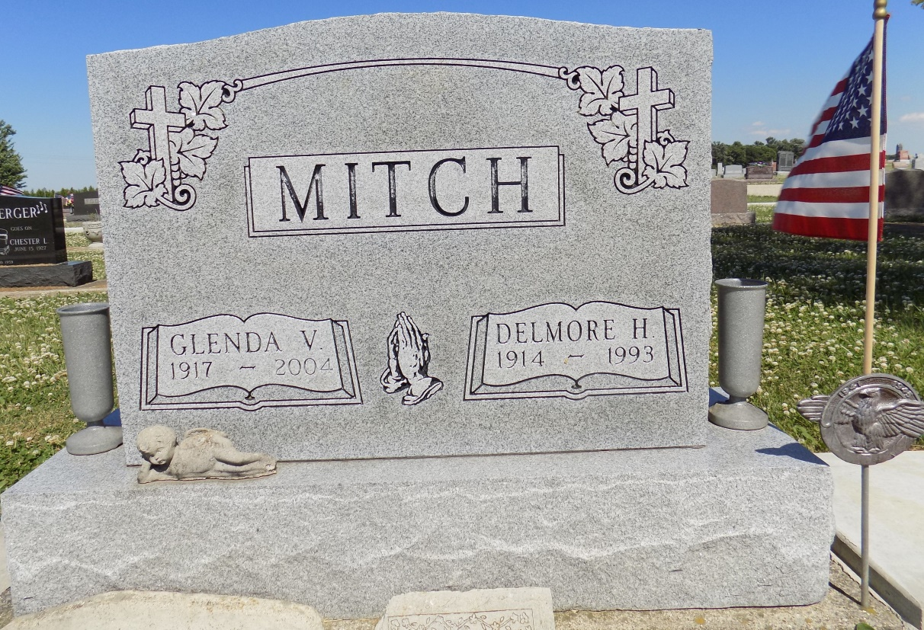

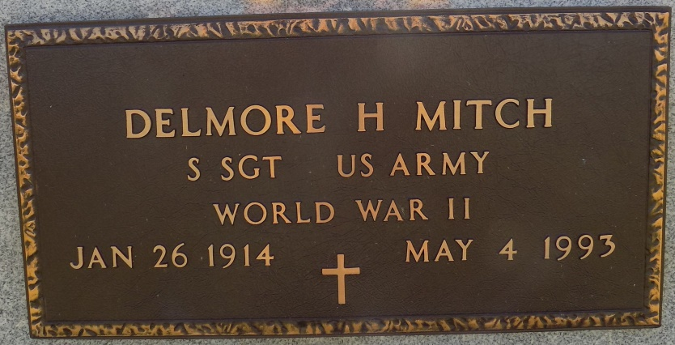
Photo by Margie Roop Pearce

DELMORE H. MITCH, 79, of Monroe died yesterday at home. The Adams County native retired in 1976 from International Harvester Co. after 28 years and also farmed. He was a veteran of World War II. Surviving are his wife, Glenda; a daughter, Aleta Weiss of Monroe; two grandchildren; and a great-grandchild. Services are 10:30 a.m. Friday in Zwick, Sefton & Jahn Funeral Home, Decatur, where calling is 2 to 9 p.m. tomorrow. Burial will be with military honors in Ray Cemetery. Preferred memorials are gifts to Adams County Home Health or Willshire (Ohio) United Brethren in Christ Church.

News-Sentinel, The (Fort Wayne, IN) - Wednesday, May 5, 1993

Contributed by Jane Edson

