Elizabeth T. (Roudebush) Oliver
March 8, 1930 – February 3, 2009

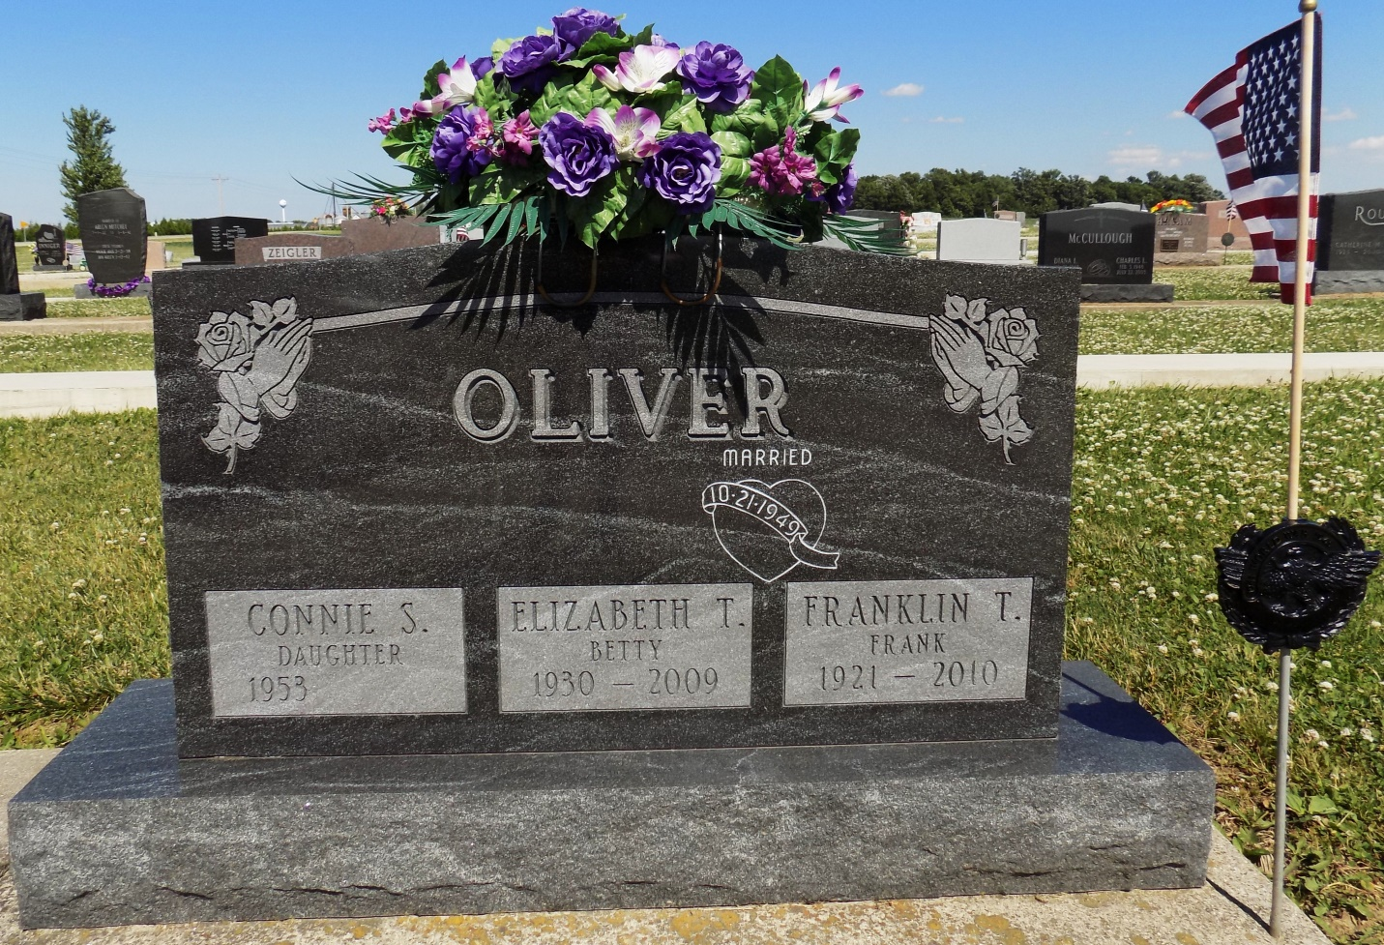
Photo by Margie Roop Pearce

Elizabeth T. ”Betty” Oliver, 78, of Monroe, Indiana passed away at her residence Tuesday, February 3, 2009. Betty was born on March 8, 1930 in Monroe, Indiana to the late Wilbur & Margaret (Coyne) Roudebush. She married Frank on October 21, 1949. Betty was a member of Pleasant Dale Church of the Brethren and was a homemaker.
She is survived by her husband Frank Oliver of Monroe; two sons Rex (Eileen) Oliver of Decatur, Jim (Tammy) Oliver of Monroe; four daughters Sandy (Bill) Crone of Decatur, Connie Oliver of Bluffton, Lisa Oliver (fiancé Rod Ross) of Monroe and Kathy (Jason) Saam of Van Wert, Ohio; 10 grandchildren and 6 great grandchildren. She is preceded in death by three brothers.
Calling hours are 1-4 and 5-8 pm on Thursday, February 5, 2009 at Haggard & Sefton Funeral Home and from 9:30-10:30 at the church on Friday. Funeral services will be held at 10:30 am Friday, February 6, 2009 at Pleasant Dale Church of the Brethren. Rev. Jay Carter will be officiating and burial will following in Ray Cemetery, Monroe. Memorials are to Family Hospice of Northeast Indiana or Pleasant Dale Church of the Brethren.

Haggard-Sefton & Hirschy Funeral Home online obit (accessed 1/2/2015)

