Ida (Hilgemann) Peters
November 13, 1884 – July 18, 1941

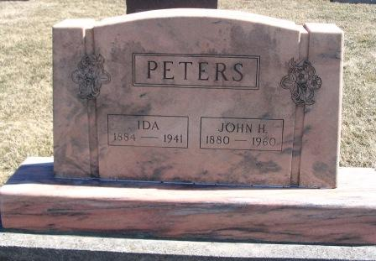
Photo by Barbara Baker Anderson

(Handwritten date: Saturday, July 19, 1941)
DEATH CLAIMS MRS. PETERS
Funeral Services For Mrs. John Peters Monday Afternoon
Funeral services for Mrs. John Peters, well known Preble township lady who died late Friday will be held Monday afternoon at 2:30 o'clock (CDT) at the Magley Evangelical and Reformed Church.
The Rev. David Grether will officiate and burial will be in the church cemetery.
(cut) ...township November 13, 1884, the daughter of William and Lizetta Hilgemann. She was married to John H. Peters on February 3, 1910.
Death was unexpected, although she had been in failing health for the past two years.
Surviving, besides the husband, are a brother, John Hilgemann of Preble township, and two sisters, (cut) and Mrs. Ed Reppert of Decatur.
The body will be removed to the residence from the Zwick funeral home this afternoon and may be viewed after 7 p.m. until time of the services.
Adams County Historical Museum
1940-1941a Scrapbook, image 58
Transcribed by Karin King

