Rhonda Teres Worthman
April 14, 1963 – April 15, 1963

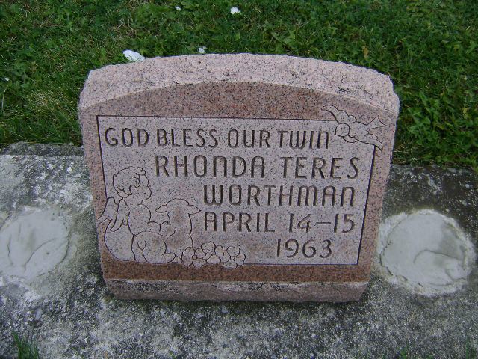
Photo by Bruce Sonner
One Of Worthman Twin Girls Dies
Rhonda Teres Worthman, infant twin daughter of Calvin and Lorraine Elgin-Worthman, of Decatur route 4, died at 10:50 p.m. Monday at the Adams county memorial hospital, where the twins were born Sunday evening.
Surviving are the parents; the twin sister, Rena Tyann; one brother, Scott; and the grandparents, Mrs. Ernest Worthman of Richburg, S.C., and Mr. and Mrs. Claude Elgin of Cumberland, Va. Graveside services, conducted by the Zwick funeral home, will be held at 4 p.m. today at the Salem United Church of Christ cemetery, the Rev. H. E. Settlage officiating. (Tues. April 16, 1963)
Berne Library Heritage Room
Adams County Obits 1962-1964
Transcribed by Janice Vasilovski

