Robert J. McIntosh
April 1, 1933 – May 21, 2017
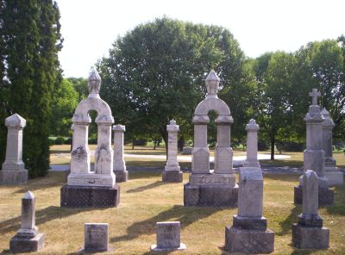
Photo by SixDogTeam
Robert J. McIntosh, 84 years old of Hoagland, Indiana, passed away on Sunday, May 21, 2017 at Adams Heritage in Monroeville.
He was born on Saturday, April 1, 1933 in Allen County, Indiana the son of the late Ralph W. McIntosh and the late Nellie (Harp) McIntosh. He married Virginia L. Gerke on May 4, 1958 at St. Peter Lutheran Church, Fuelling and she preceded him in death on July 18, 2015.
An honorably discharged veteran, Bob served his country in the United States Army from May 1953 through May 1955.
Bob was a member at St. John Lutheran Church, Bingen where he was the longtime financial secretary and member of the Bingen choir. He was also a member of the Hoagland Area Advancement Association (HAAA) and the American Legion Post #420 in Monroeville. Bob was a long time 4-H leader of Shooting Sports in Allen County. He enjoyed camping, traveling, playing games and cards especially with his grandchildren. He worked for Tokheim Corporation with 40 years of service and retired in 1993. He also worked on a part time basis at Patterson Do-It Best Center in New Haven, Indiana for 20+ years.
Surviving are his daughter, Danelle (Don) Emenhiser-Westrick of Hoagland, IN; son, Lyle (Beverly) McIntosh of Indianapolis, IN; brother, John (Corene) McIntosh of Avilla, IN; sister, Mary (Karl) Monnier of New Smyrna Beach, FL; three grandchildren, Jessica (Ben) Koenemann; Bethany Emenhiser; & Emma McIntosh; two great-grandsons, Charlie Koenemann & Ezekiel Koenemann and another great-grandson, James Koenemann, due in June. Preceding Robert in death was a brother, Paul E. McIntosh.
Funeral services will be held at 11:00 a.m. Saturday, May 27, 2017 at St. John Lutheran Church, Bingen with Pastor Peter J. Brock officiating. Interment will follow in the St. John Lutheran Cemetery, Bingen. Friends will be received from 4 to 8 p.m. Friday, May 26 at Zwick & Jahn Funeral Home in Decatur and one hour prior to the service at the church on Saturday.
Preferred memorials are to St. John Lutheran Church, Bingen 175th Tanzania Mission Offering or Worship for Shut Ins.

Zwick & Jahn Funeral Home online obit (accessed 5/23/2017)

