Ronald Dean Schuller
July 5, 1940 - July 6, 1940
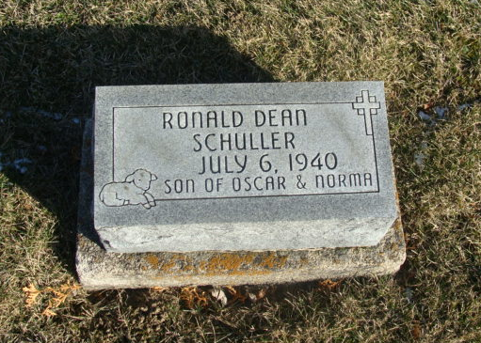
Photo by Alicia Kneuss

SCHULLER
Decatur, July 8 -
Funeral services for Rolland Schuller, infant son of Mr. and Mrs. Oscar Schuller of Root Township, who died yesterday morning at the Adams County Memorial Hospital, 20 hours after birth, were held yesterday afternoon at the Schuller residence. Burial was in St. John’s Lutheran Cemetery.
Journal-Gazette, Fort Wayne, IN; July 9, 1940
Contributed by Jim Cox

