Ollis Dean Whitacre
August 8, 1931 – January 5, 2017
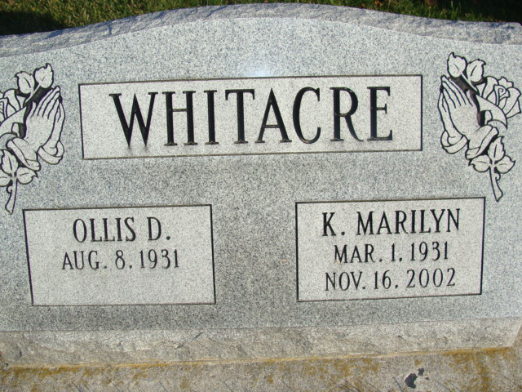
Photo by Alicia Kneuss

Ollis Whitacre
August 8, 1931 - January 5, 2017

Ollis D. "Ollie" Whitacre, 85 years old of Warsaw, IN, passed away on Thursday, January 5, 2017 in Warsaw Meadows Care Center in Warsaw, IN.
He was born on August 8, 1931 in Pennville, Indiana the son of the late Samuel Albert Whitacre and the late Lelia Myrtel (Bond) Whitacre. He married Katherine M. “Marilyn” Farmer on December 23, 1958 in Costa Mesa, California and she preceded him in death on November 16, 2002.
Ollie served his country in the United States Navy from 1951 to 1955 and was honorably discharged. He was a member of St. John Lutheran Church, Bingen in Decatur. Ollie was a graduate of Pennville High School in 1949. He had worked at Kitty Hawk in Fort Wayne as a security guard until they closed and prior to that had worked at an injection molding plant in Garrett, Indiana.
Surviving are his daughter, Cynthia K. Whitacre of Columbia City, IN; son, Clayton D. Whitacre of Decatur, IN; 8 Grandchildren; Numerous great-grandchildren; and several nieces and nephews.
Preceding Ollie in death were a son, Edward A Whitacre; a grandson; three sisters: Evelyn Whitacre; Ruth Ellen Geesman; and Lavanda Wentz; and four brothers: John Whitacre; Frederick Whitacre; LeRoy Whitacre; and Hollis Whitacre.
Funeral services will be held at 2:00 p.m. Monday, January 9, 2017 in the St. John Lutheran Church, Bingen with Rev. Peter Brock officiating. Interment will follow in the St John Lutheran Cemetery, Bingen with Military Graveside Services being conducted by the American Legion Post #43 of Decatur. Friends will be received one hour prior to services at the church on Monday.
Preferred memorials are to the family.

Zwick & Jahn Funeral Home online obit (accessed 1/9/2017)

