PFC Victor Schueler
January 23, 1924 – August 3, 1945

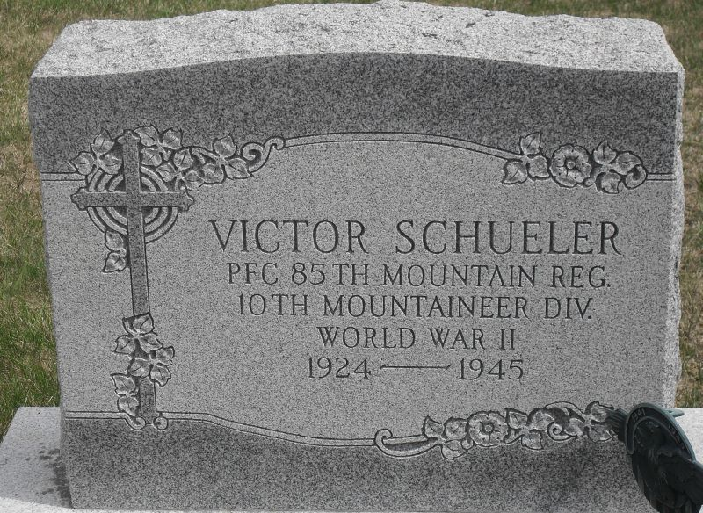
Photo by Stephen & Andrea Brangan

VICTOR SCHEULER DIES IN ITALIAN HOSPITAL
Soldier Dies Aug. 3 of Kidney Infection

Pfc. Victor Scheuler (sic), 21, a combat infantryman with the 85th Mountain Regiment of the 10th "Mountaineer" division, son of Mr. and Mrs. Adolph Scheuler of Preble township, died in a hospital in Italy on August 3, of a kidney infection, the parents were notified last evening.
Wounded in action on April 14, Pfc. Scheuler apparently had fully recovered from his wounds and returned to his company and active duty. His parents did not know when he was stricken with the fatal illness. His mother stated that he had suffered from an attack of gall stones a few months ago.
The young soldier, who had been honored with the combat infantryman badge for his military exploits, entered the army on August 18, 1944 and took basic training at Camp Hood, Texas. He shipped for overseas last January.
Pfc. Scheuler was born in Preble township on January 23, 1924. He attended the Preble Lutheran school and was a member of the Preble Lutheran church.
Besides his parents, he is survived by a brother, Martin and one sister, Miss Olga Scheuler, at home, the latter being employed at the General Electric plant in this city.

Decatur Daily Democrat, Adams County, Indiana; Tuesday, Aug. 14, 1945

Contributed by Karin King

