Wilhelmine M. (Buuck) Reese
January 18, 1831 – December 25, 1894

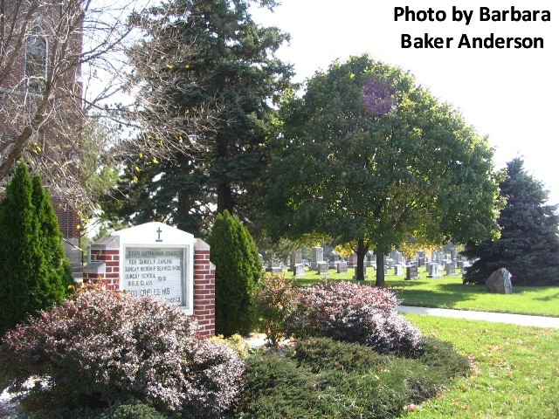

Mrs. Welhelmina Reese died last evening of a complication of diseases at the age of 64 years. She came to Fort Wayne three weeks ago to visit Capt. Chas. Reese and family, at 131 Montgomery street. Her husband, Ehlert Reese, of Adams county, is a brother of Capt. Reese. The remains were shipped to Adams county this afternoon for interment.

Fort Wayne News, Allen County, Indiana; Dec. 26, 1894

Contributed by Karin King

