Richard H. Scheumann
April 4, 1920 – April 11, 2018
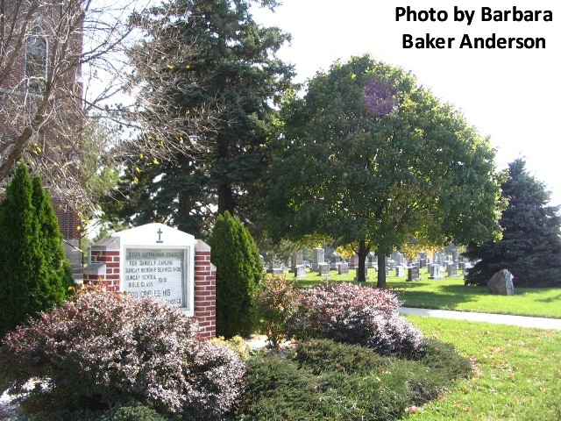
Richard H. Scheumann, 98, of Decatur, Indiana passed away early Wednesday, April 11, 2018 at Adams Heritage in Monroeville, Indiana.
He was born on April 4, 1920 in Hoagland, Indiana to the late Julius Scheumann and the late Rosa (Luttman) Scheumann. Richard was united in marriage to Eldora L. Meyer on September 7, 1946 at the Bethlehem Lutheran Church in Ossian, Indiana. She preceded him in death on January 11, 2009 following 62 years of marriage.
Richard enlisted in the United States Army on April 24, 1944 and served his country during WWII reaching the rank of Private First Class. He was deployed to Europe, Italy, and Austria before being honorably discharged on April 23, 1946.
He was a member of the Zion Lutheran Church, Friedheim where he formerly served as President, Trustee and Elder. Richard was a past member of the American Legion Post #43, Adams County Soil & Water Conservation where he also served on the Board from 1953 until 1991, and he also served on the Wayne County and Adams County Co-op Boards and Farm Bureau Inc. Board.
Richard was a school bus driver for North Adams Community Schools for 40 years before retiring in December 1989. He was also a self-employed dairy farmer before retiring in 1980 but still enjoyed farming with his grandson until 2013 when his health prevented him from continuing. He was also the director of German Echo Mutual Insurance for 19 years.
He is survived by three daughters, Shirley Gehres of Decatur, Judy (Jerry) Ulman of Raleigh, NC, & Karen Hall of Fort Wayne; son, Don A. (Dee) Scheumann of Greenfield, IN; two brothers, Robert (Ruth) Scheumann & Alfred (Mary Scheumann) both of Hoagland; sister, Alvera Knipstein of Hoagland; sister-in-law, Helen Scheumann of Ossian; ten grandchildren; & 17 great-grandchildren.
He was preceded in death by his brother, Edward Scheumann and two sons-in-law, Donald Gehres & John Hall.
Funeral services will be held at 11:30 a.m. Saturday, April 21, 2018 at Zion Lutheran Church, Friedheim with Rev. Daniel Dahling officiating. Burial will follow at Zion Lutheran Cemetery, Friedheim with Military Graveside Honors to be conducted by the American Legion Post #43 of Decatur.
Family & friends will be received from 2 to 5 p.m. and 6 to 8 p.m. p.m. Friday, April 20, 2018 at Zwick & Jahn Funeral Home in Decatur and on Saturday from 10:30 a.m. to 11:15 a.m. prior to service at the church.
In lieu of flowers, memorial donations in honor of Richard can be given to Zion Lutheran Church Friedheim Expansion Fund; Worship Anew; or Zion Lutheran Friedheim Radio Fund. If you are unable to be present for the services, memorials can be made payable to the organization listed & mailed to Zwick & Jahn Funeral Home in Decatur.

Zwick & Jahn Funeral Home online obit (accessed 4/13/2018)

