Homer Krick
December 6, 1868 – September 21, 1937

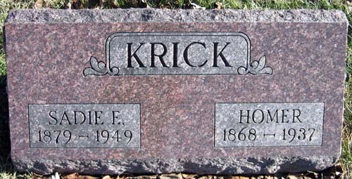
Photo by Greg Michell

Last Rites Friday (photo)

Homer Krick Funeral services for Homer Krick, aged 69, will be held Friday at 10 a.m. at the home, 1152 Glasgow Avenue, and at 10:30 a.m. at the Faith Tabernacle with the Rev. F. W. Battenberg officiating. Burial at Monmouth near Decatur. Mr. Krick, who was Republican precinct committeeman for the Fortieth District, died Tuesday morning at the Methodist Hospital.

Fort Wayne News Sentinel, Allen Co, IN; Wednesday, 22 September 1937, p. 13

*****
FRICK (sic)
Funeral services for Homer Kirck (sic), 69, who died at 9:10 o'clock Tuesday morning at the Methodist Hospital will be held Friday morning at 10 o'clock at the residence at 1152 Glasgow Avenue, and 10:30 o'clock at the Faith Tabernacle on Fairfied Avenue, Rev. William Battenburg officiating. Burial will be at Monmouth, near Decatur. The body will be taken home from L. C. Brudi & Sons Funeral Home at 5 o'clock this afternoon. The deceased was Republican precinct committeeman for the Fortieth District, and had been active in politics the past 33 years. He was employed as a caretaker at Reservoir Park. Survivors include the widow, Sadie, and two sisters, Mrs. James Smith and Mrs. Sarah Steel, all of this city.

Journal Gazette, Fort Wayne, Allen County, Indiana, Wednesday, September 22, 1937

