Georgia Zeigler
November 22, 1890 – May 29, 1898

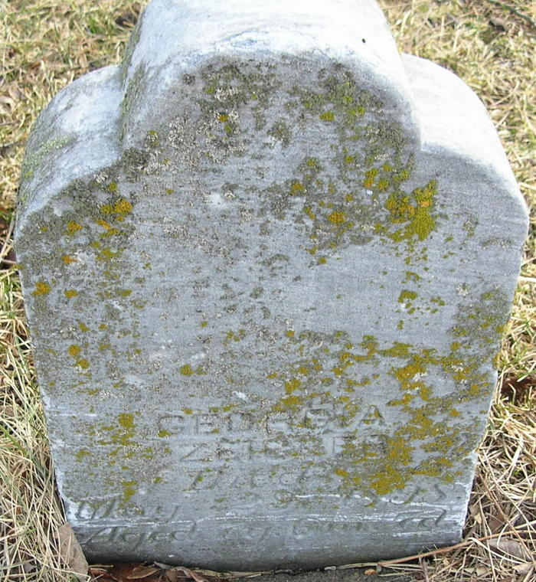
Photo by JC

Georgia Zeigler, daughter of Dr. Zeigler and wife, died Sunday at the youthful age of seven years. She was one of the brightest scholars in our schools and loved by all her playmates. Funeral occurred Monday, Rev. Watts officiating.

Hand dated by June 2, 1898

Monmouth Cemetery – A Record of All Known Burials in the Monmouth Cemetery, compiled by Nola Rains, 2002.

