Nettie (Shackley) Spangler
April 3, 1871 – July 22, 1929

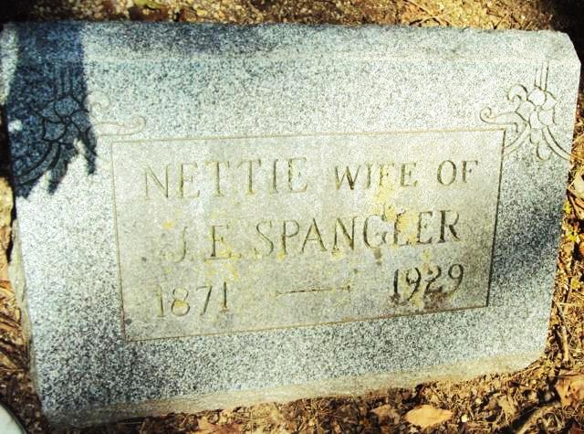

FARM WOMAN DIES SUDDENLY
Mrs. Nettie Spangler Fatally Stricken With Heart Trouble Today

Mrs. Nettie Spangler, 58, wife of Jacob Edward Spangler, died suddenly at 4:30 o'clock, this morning, Monday, July 22, 1929, at her home seven mies (sic) northwest of Decatur. Mrs. Spangler had attended church as usual yesterday. She arose early this morning and got breakfast over, with the expectation of preparing dinner for threshers. It was while she was in the midst of these duties that she was fatally stricken.
Mrs. Nettie Spangler was the daughter of Howard and Samantha Shackely and was born April 3, 1871, in Unon township, Adams county, where the major portion of her life was spent. She united in marriage, January 18, 1900, with Jacob Edward Spangler.
Three children, born of this union, preceded the mother in death. Surviving, besides the husband, are the following brothers and sisters: Mrs. Effie Bowers, of near Peterson; Mrs. Bertha Johnston, of Fort Wayne; Miss Jennie Shackley, of Kenton, Ohio; and Samuel Shackley, of Bryan, Ohio.
Funeral services will be held Wednesday afternoon at 1:30 o'clock (standard time) at the residence and at 2 o'clock at the Mt. Pleasant M. E. church. The Rev. Glen Bryan, of Wells county, will officiate and burial will be made in the Reynolds cemetery.
Nola Rains NOTES: Spangler, Nettie; 1871 - 12 Apr 1905; Wife of Jacob Edward Spanger; daughter of Howard & Samantha (Kern) Shackley.
From Reynolds Cemetery Book by Nola Rains - no name or date of paper

*****
MRS. J. SPRANGLER [sic] DIES SUDDENLY
Wife of Farmer Stricken By Heart Attack Early This Morning

Mrs. Nettie Spangler, 58, wife of Jacob Edward Spangler, died suddenly of a heart attack at 4:30 o'clock this morning, at her home seven miles northwest of Decatur.
She had arisen apparently in good health this morning and prepared the family breakfast and had begun the preparations of a dinner for threshers when she was fatally stricken.
Surviving are the husband and the following brothers and sisters, Mrs. Effie Bowers, near Petroleum; Mrs. Bertha Johnston, of Fort Wayne; Miss Jennie Shackley, Kenton, Ohio, and Samuel Shackley, Bryant, Ind.
Three children are dead.
The funeral will be held at 1:30 o'clock Wednesday afternoon at the Mt. Pleasant church, Adams county, and Rev. Glen Bryan, of Wells county, will be in charge. Burial will be in the Reynolds cemetery.
Bluffton Evening News, Wells County, Indiana; Monday, July 22, 1929
*****
Decatur, July 12 - Mrs. Nettie Spangler, 53, the wife of Jacob Edward Spangler, died suddenly of heart trouble at her home seven miles northwest of Decatur.
Mrs. Spangler appeared to be in good health when she arose this morning and prepared a breakfast. After breakfast, she started preparations for cooking a dinner for threshers today and it was then that she was stricken.
Mrs. Spangler was born in Adams County April 3, 1871. She was married to Jacob Edward Spangler January 13, 1906. Three children preceded her in death.
Surviving are the husband and the following brothers and sisters: Mrs. Eggie Bowers of near Peterson; Mrs. Bertha Johnston of Fort Wayne; Miss Jennie Shackley of Kenton, O., and Samuel Shackley of Bryan, O.
Funeral services will be held at the Mt. Pleasant M. E. Church in Adams County at 2 o'clock Wednesday afternoon with Rev. Glen Bryan officiating. Burial will be made in the Reynolds Cemetery.

Journal-Gazette, Fort Wayne, IN; August 13, 1929, Page 11

