Fred J. Baker
July 29, 1914 – July 22, 1963

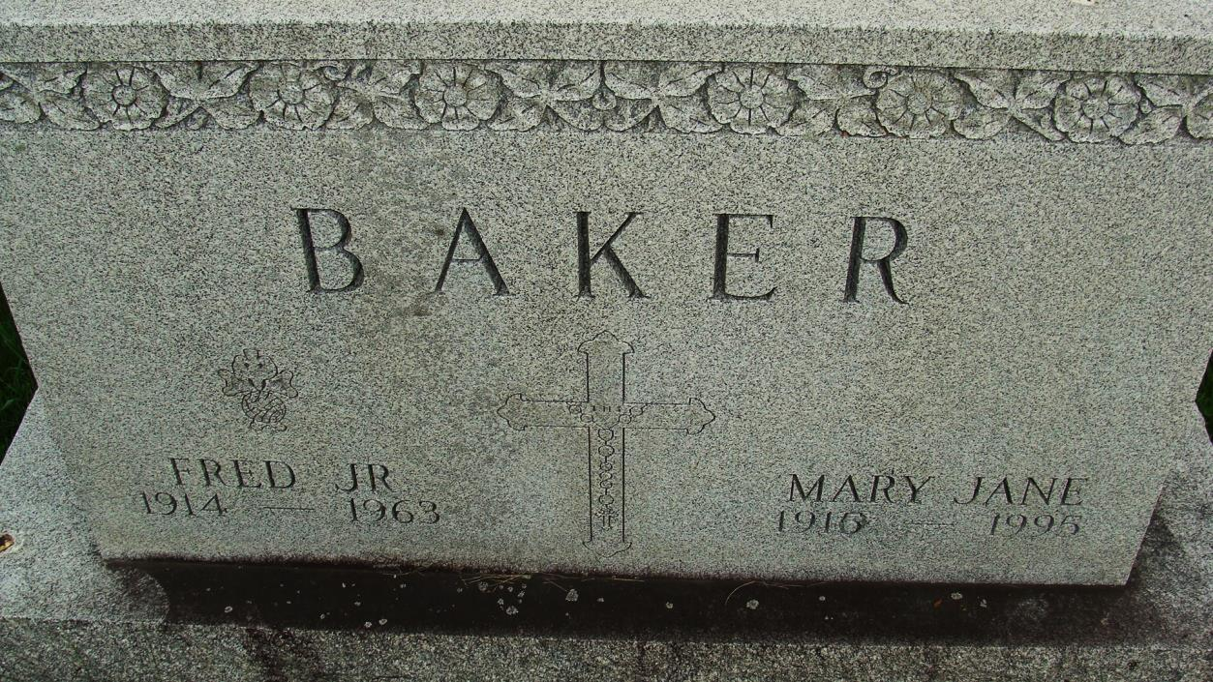
Photo by Alicia Kneuss

Fred Baker, Jr. Dies Early This Morning

Fred (Pappy) Baker, Jr., 48, prominent painting contractor in Decatur and Fort Wayne and area, died at 6:30 o’clock this morning at his home, 511 Limberlost drive. He had been in failing health for several months but his death was unexpected.
Born in Decatur July 29, 1914, he was a son of Fred and Amelia Kohne-Baker, and was a lifelong resident of this city. He was married to the former Mary Jane Schafer July 15, 1939.
Mr. Baker was a member of St. Mary’s Catholic church, the Holy Name society, and was a Fourth Degree Knights of Columbus member.
Surviving are his wife; two sons, Gerald and Jim Baker, both of Decatur, two daughters, Victorine and Barbara Baker, both at home; his mother, Mrs. Amelia Baker of Decatur; four brothers, Harold, Arthur, Eugene and William Baker, all of Decatur, and three sisters, Mrs. Alice Fullenkamp and Mrs. Mary Ann Inskeep, both of Decatur, and Mrs. Lucille Philips of South Bend.
The body was removed to the Gillig & Doan funeral home, where friends may call after 2 o’clock Tuesday afternoon. Funeral arrangements have not been completed. (Mon. July 22, 1963)
****

Baker Funeral Rites Thursday Morning

Funeral services for Fred Baker Jr., well known painting contractor who died Monday morning, will be conducted at 9:30 a.m. Thursday at St. Mary’s Catholic church. The Rt. Rev. Msgr. Simeon Schmitt will officiate and burial will be in the Catholic cemetery.
Friends may call at the Gillig & Doan funeral home until time of the ser4vices. The Holy Name society will recite the rosary at 8 p.m. Wednesday. The Fourth Degree Knights of Columbus will post an honor guard at the funeral home from 7-9 p.m. Wednesday and will also serve as honorary pallbearers. (Tues. July 23, 1963)

Heritage Room, Berne (IN) Library
Adams County Obits 1962-1964, image 33
Transcribed by Janice Vasilovski

