Margaret Rose (Rumschlag) Becker
February 26, 1916 – August 23, 1994
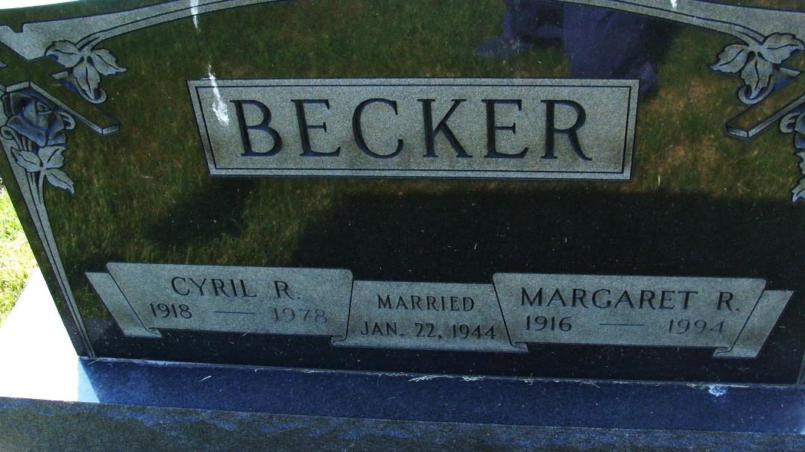
Photo by Alicia Kneuss
Margaret R. Becker, 78, died Tuesday at her home. She retired from First State Bank, Decatur after 40 years. Her husband, Cyril, died in 1978.
Surviving are a son, John R. of West Bloomfield, Mich.; three daughters, Louann Maldeney of Florissant, Mo., Alice M. Friedt and Patricia Johnson, both of Decatur; six brothers, Cletus Rumschlag and Thomas Rumschlag, both of Fort Wayne and Brother Dennis Rumschlag of Carthagena, Ohio, and Jerome Rumschlag and Herman Rumschlag, both of Decatur; seven sisters, Sister Clare Anne Rumschlag of Columbus, Ohio, Jean Rumschlag of Wauwatosa, Wisc., Mary Catherine Rumschlag of Big Stone Gap, Va., Esther Rosenbeck of St. Henry, Ohio, Dolores Schmit of Portland, Monica Wyss of Coldwater, Mich., and Rita Girard of Decatur; and nine grandchildren.
Prayer services at 9:40 am Friday at Zwick-Sefton & Jahn Funeral Home, Decatur. Mass at 10 am Friday at St. Mary of the Assumption Catholic Church, Decatur. Calling from 2 to 5 and 7 to 9 pm Thursday, with a rosary service at 8:30 pm at the funeral home. Burial in St. Joseph Catholic Cemetery, Decatur. Memorials to St. Mary’s Improvement Fund or Home Health.
Fort Wayne Journal-Gazette (IN); August 24, 1994, Page 3C
Contributed by Jim Cox

