Craig Allan Butler
December 27, 1957 – May 26, 1969

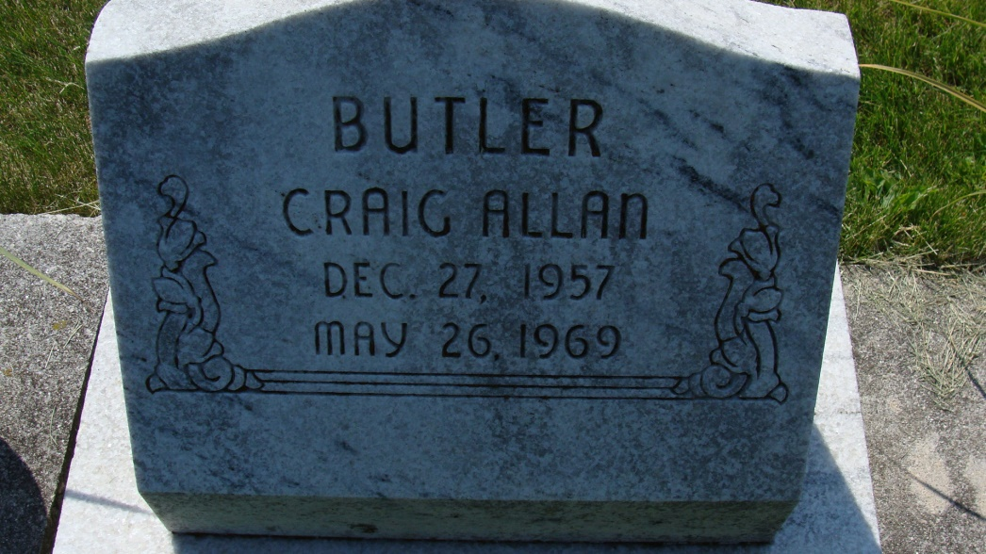
Photo by Alicia Kneuss

11-year-old Decatur boy killed Monday evening when bicycle struck by freight at crossing

Tragedy struck Decatur late Monday evening when 11-year-old Craig Allen Butler, son of Mr. and Mrs. William Butler, of 1216 N. Second St., died at 11:17 p.m. at the Fort Wayne Lutheran hospital of injuries he received earlier in the evening when he was struck by a slow moving Erie-Lackawanna freight train at the Mercer Ave. crossing.
The lad died at the Fort Wayne hospital while undergoing surgery.
The accident took place at approximately 7:02 Monday as Craig was returning home on his bicycle from White Sox little league practice which had been held earlier at the Homestead baseball diamond.
Craig was riding his bicycle at the time the accident occurred and was in the cross walk when he was struck by a box car which was traveling on the east bound track. The boy was proceeding north on his bicycle and was on the east side of Mercer Ave. when he was struck by the box car. The freight train was backing up at the time and there were approximately eight other box cars behind the one that struck Craig. After the impact, the box car carried the boy down the track several feet.
The flashers were working and the gate was down at the Mercer Ave. crossing at the time. The engineer of the train was J. L. Werner, of Marion, O., the fireman was T.K. Barker of Huntington and conductor was Loren H. Dolby, also of Huntington.
The accident is still under investigation by the Decatur police department and the county coroner’s office. Chief of police Grover Odle disclosed late this morning that anyone who witnessed the accident should contact the police department immediately.
It was learned this morning that Monday evening’s accident may not be termed as a traffic fatality because the boy was in the cross walk, not the street, at the time the mishap occurred. If the accident is recorded as a traffic fatality, it will be the first in Decatur since June 15, 1968. The bureau of motor vehicles will, in all probability, make the final ruling on whether the accident will be termed a traffic fatality.
Funeral Thursday
The victim of the tragedy was born in Decatur Dec. 27, 1957, the son of William and Ruth Rumschlager-Butler, and has resided in Decatur his entire life.
The lad, a fourth grade student at St. Joseph school, was a member of St. Mary’s Catholic church, the Children’s sodality, and was a member of the White Sox Little League baseball team.
Surviving in addition to the parents are two sisters, Louise and Denise Butler, and a brother Brad Butler, all at home; and the paternal grandparents, Mr. and Mrs. Nile Butler of Decatur route 1. One sister preceded him in death.
Funeral services will be conducted at 10 a.m. Thursday at St. Mary’s Catholic church with the Rt. Rev. Msgr. Simeon Schmitt officiating. Burial will be in the Catholic cemetery. Friends may call at the Gillig-Doan & Sefton funeral home after 12 noon Wednesday until time of the services. The rosary will be recited at 8p.m. Wednesday. (May 27, 69)

Decatur (IN) Public Library
Obit Book E, image 36, p. 32
Transcribed by Janice Vasilovski

