James H. Cochran
November 28, 1925 – September 4, 2017

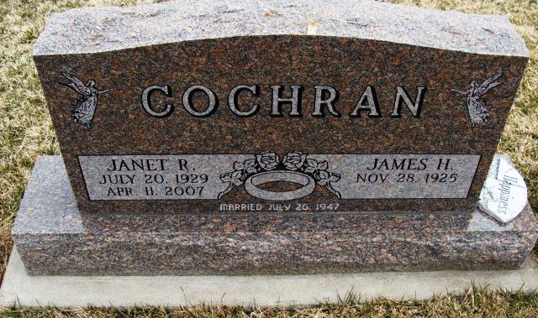
Photo by Alicia Kneuss

James H. “Hez” Cochran, Sr, ,91, of Decatur, Indiana passed away at the Genesis Healthcare, New Haven, IN on Monday, September 4, 2017. He was born on November 28, 1925 to the late Hubert and Zelda F. (Melchi) Cochran. On July 26, 1947, he married Janet R. Zeser. She passed away on April 11, 2007
He was a graduate of Decatur High School class of 1944. He served his country as a Staff Sargent in the U.S. Army during WWII in the European Theatre and was in The Battle of the Bulge. Jim was the recipient of 2 Purple Hearts, a Bronze Star and Presidential Unit Citation.
Jim was a parishioner of the St. Mary of the Assumption Catholic Church, its Holy Name Society, and the Knights of Columbus Msgr. J.J. Seimetz Council 864. He was also a member of the American Legion Post 43 and the Moose Lodge 1311. He worked for Phelps Dodge for 22 years and prior to that was an officer with the Decatur Police Department, serving for 15 years. He enjoyed his memories at Cedar Lake, listening to audio books, and spending time with his family.
He is survived by 5 sons, James H. (Becky) Cochran, Jr.; Kim D. (Teresa) Cochran; Kevin J. (Becky) Cochran; and Kent Cochran all of Decatur, IN; Jeff L. Cochran of Kihei, HI; 2 daughters, Brenda K. (John) Schultz and Debra S. (Willie) Hackman both of Decatur, IN; 1 brother-in-law, Tom Zeser of Decatur, IN; 18 grandchildren and 27 great grandchildren with 2 on the way.
He was preceded in death by a brother, Sephus Jackson and a sister, Cate Smith.
Visitation will be held from 3:00 – 8:00 p.m. on Thursday, September 7, 2017, at Haggard-Sefton & Hirschy Funeral Home, with a reciting of the Holy Rosary at 2:15 p.m. A Prayer Service will be held at 9:20 a.m. at Haggard-Sefton & Hirschy Funeral Home followed by a Mass of Christian Burial on Friday, September 8, 2017 at 10:00 a.m. at the St. Mary of the Assumption Catholic Church. Father Bob J. Lengerich will be officiating. Burial will take place at the St. Joseph Catholic Cemetery, with Military Graveside Rites by the American Legion Post 43 Color Guard.
Memorials may be given to the American Legion Post 43 or Disabled American Veterans.

Haggard-Sefton & Hirschy Funeral Home online obit (accessed 09/06/2017)

