Frances E. (Coffee) Colchin
September 27, 1891 – September 22, 1968
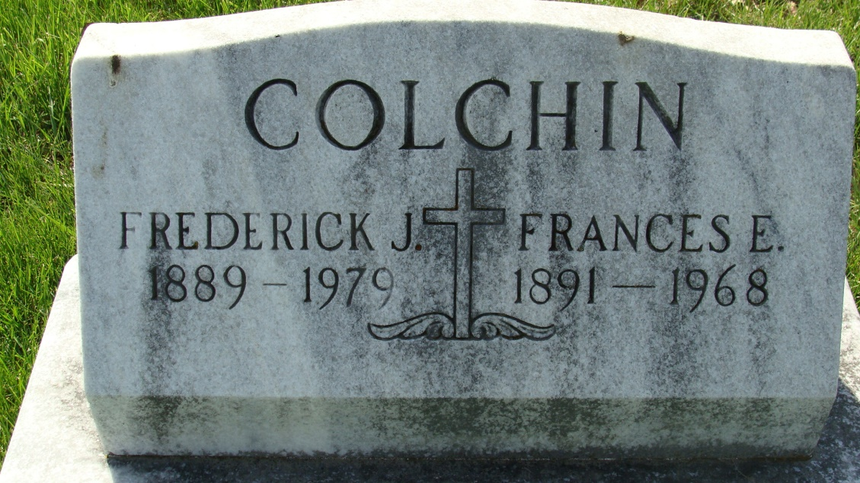
Photo by Alicia Kneuss

Mrs. Fred Colchin dies at hospital

Mrs. Frances E. Colchin, 76, lifelong resident of Adams county, wife of Fred J. Colchin, 403 Fornax street, died at 2:45 p.m. Sunday at the Adams county memorial hospital, following an illness of three weeks.
Born in Adams county Sept. 27, 1891, she was a daughter of David and Anna Hessler-Coffee. She was married to Fred J. Colchin June 2, 1914.
Mrs. Colchin was a member of St. Mary’s Catholic church, the Rosary society, and the St. Anne’s Grandmothers club.
Surviving in addition to her husband are three sons, Mark and Marucie Colchin, both of Decatur, and Max Colchin of Fort Wayne route 7; four daughters, Mrs. Arthur (Mary Jane) Miller, Mrs. Joseph (Martha) Kitson, and Mrs. Claude W. (Lois) Sharp, all of Decatur, and Mrs. Francis (Joan) Miller of Waterloo; one sister, Mrs. Edward (Mildred) Berling of Decatur; 28 grandchildren and three great-grandchildren. One daughter and three brothers are deceased.
Funeral services will be held at 10 a.m. Wednesday at St. Mary’s Catholic church, with the Rt. Rev. Msgr. Simeon Schmitt officiating. Burial will be in the Catholic cemetery. Friends may call at the Gillig-Doan & Sefton funeral home after 7 p.m. today until time of the services. The rosary will be recited at 8 p.m. Tuesday.
(Sept. 22, 1968)

Decatur (IN) Public Library Obit Book E, Image 21, p. 8
Transcribed by Janice Vasilovski

