Florence (Kipley) Des Jean
April 7, 1898 – March 7, 1960
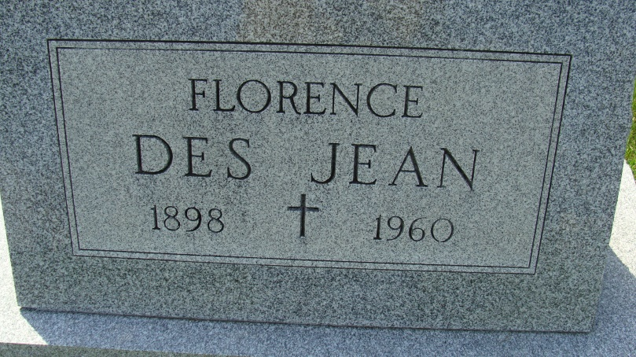
Photo by Alicia Kneuss
Dated March 7, 1960
Florence DesJean Dies This Morning
Mrs. Florence DesJean, 61, well known Decatur lady, and a clerk at the Schafer Store for many years, died suddenly at 1 o’clock this morning at the Adams county memorial hospital. She had been ill only six hours with a heart ailment and complication, and died soon after removal to the hospital.
Born in Riverdale, Ill., April 7, 1898, she was a daughter of Mr. and Mrs. Peter Kipley, and had lived in Decatur for more than 20 years, making her home with a brother-in-law and sister, Mr. and Mrs. John Neering, 338 South Third street. Her husband, Frank W. DesJean, preceded her in death in 1937.
Mrs. DesJean was a member of St. Mary’s Catholic church, the Third Order of St. Francis, the Rosary society, and the Foresters.
Surviving are one daughter, Miss Charmaine DesJean of Los Angeles, Calif.; two sons, Richard DesJean of Decatur, and Cyril DesJean of Indianapolis; 12 grandchildren, and one sister, Mrs. John Neering of Decatur.
Funeral services will be conducted at 9:15 a.m. Thursday at St. Mary’s Catholic church, the Very Rev. Simeon Schmitt officiating. Burial will be in the Catholic cemetery. Friends may call at the Gillig & Doan funeral home after 2 p.m. Tuesday until time of the services. The Rosary society will recite the rosary at 7:30 p.m. Wednesday and the Third Order of St. Francis at 8 o’clock.
Decatur (IN) Public Library
Obit Book A, p. 39
Transcribed by Janice Vasilovski

