Gertrude E. (Radermaker) Ehinger
November 12, 1884 – May 11, 1977

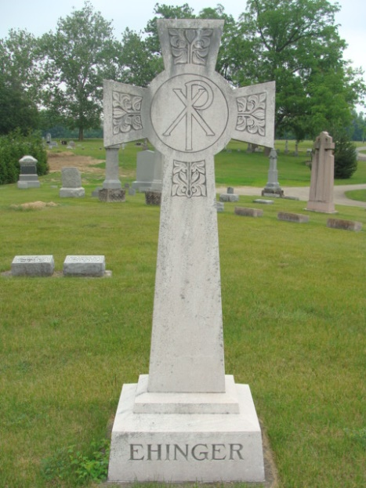

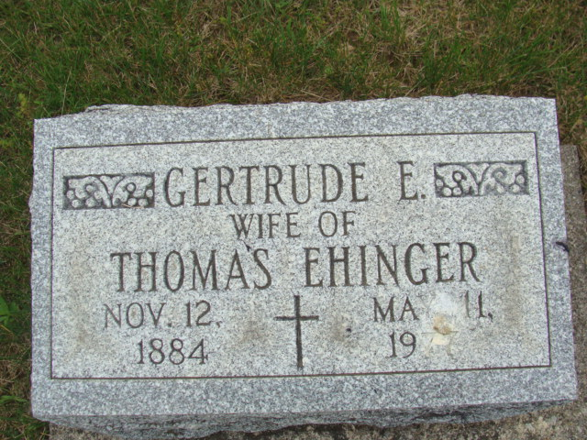
Photos by Alicia Kneuss

Mrs. Gertrude E. Ehinger, 92, mother of Edward Ehinger, Portland, died Wednesday at LaGrange County Hospital, LaGrange. She was a native of Adams County.
Surviving in addition to her son are two daughters, another son, three sisters, one brother, 10 grandchildren and 30 great-grandchildren.
Services were held Friday at St. Joseph Catholic Church, LaGrange. Burial was in St. Joseph Cemetery, Decatur.
Newspaper clipping from the Florence Gause Collection dated 1977

Contributed by Elaine Geyer

