Timothy A. Gase
July 9, 1962 – February 9, 2013

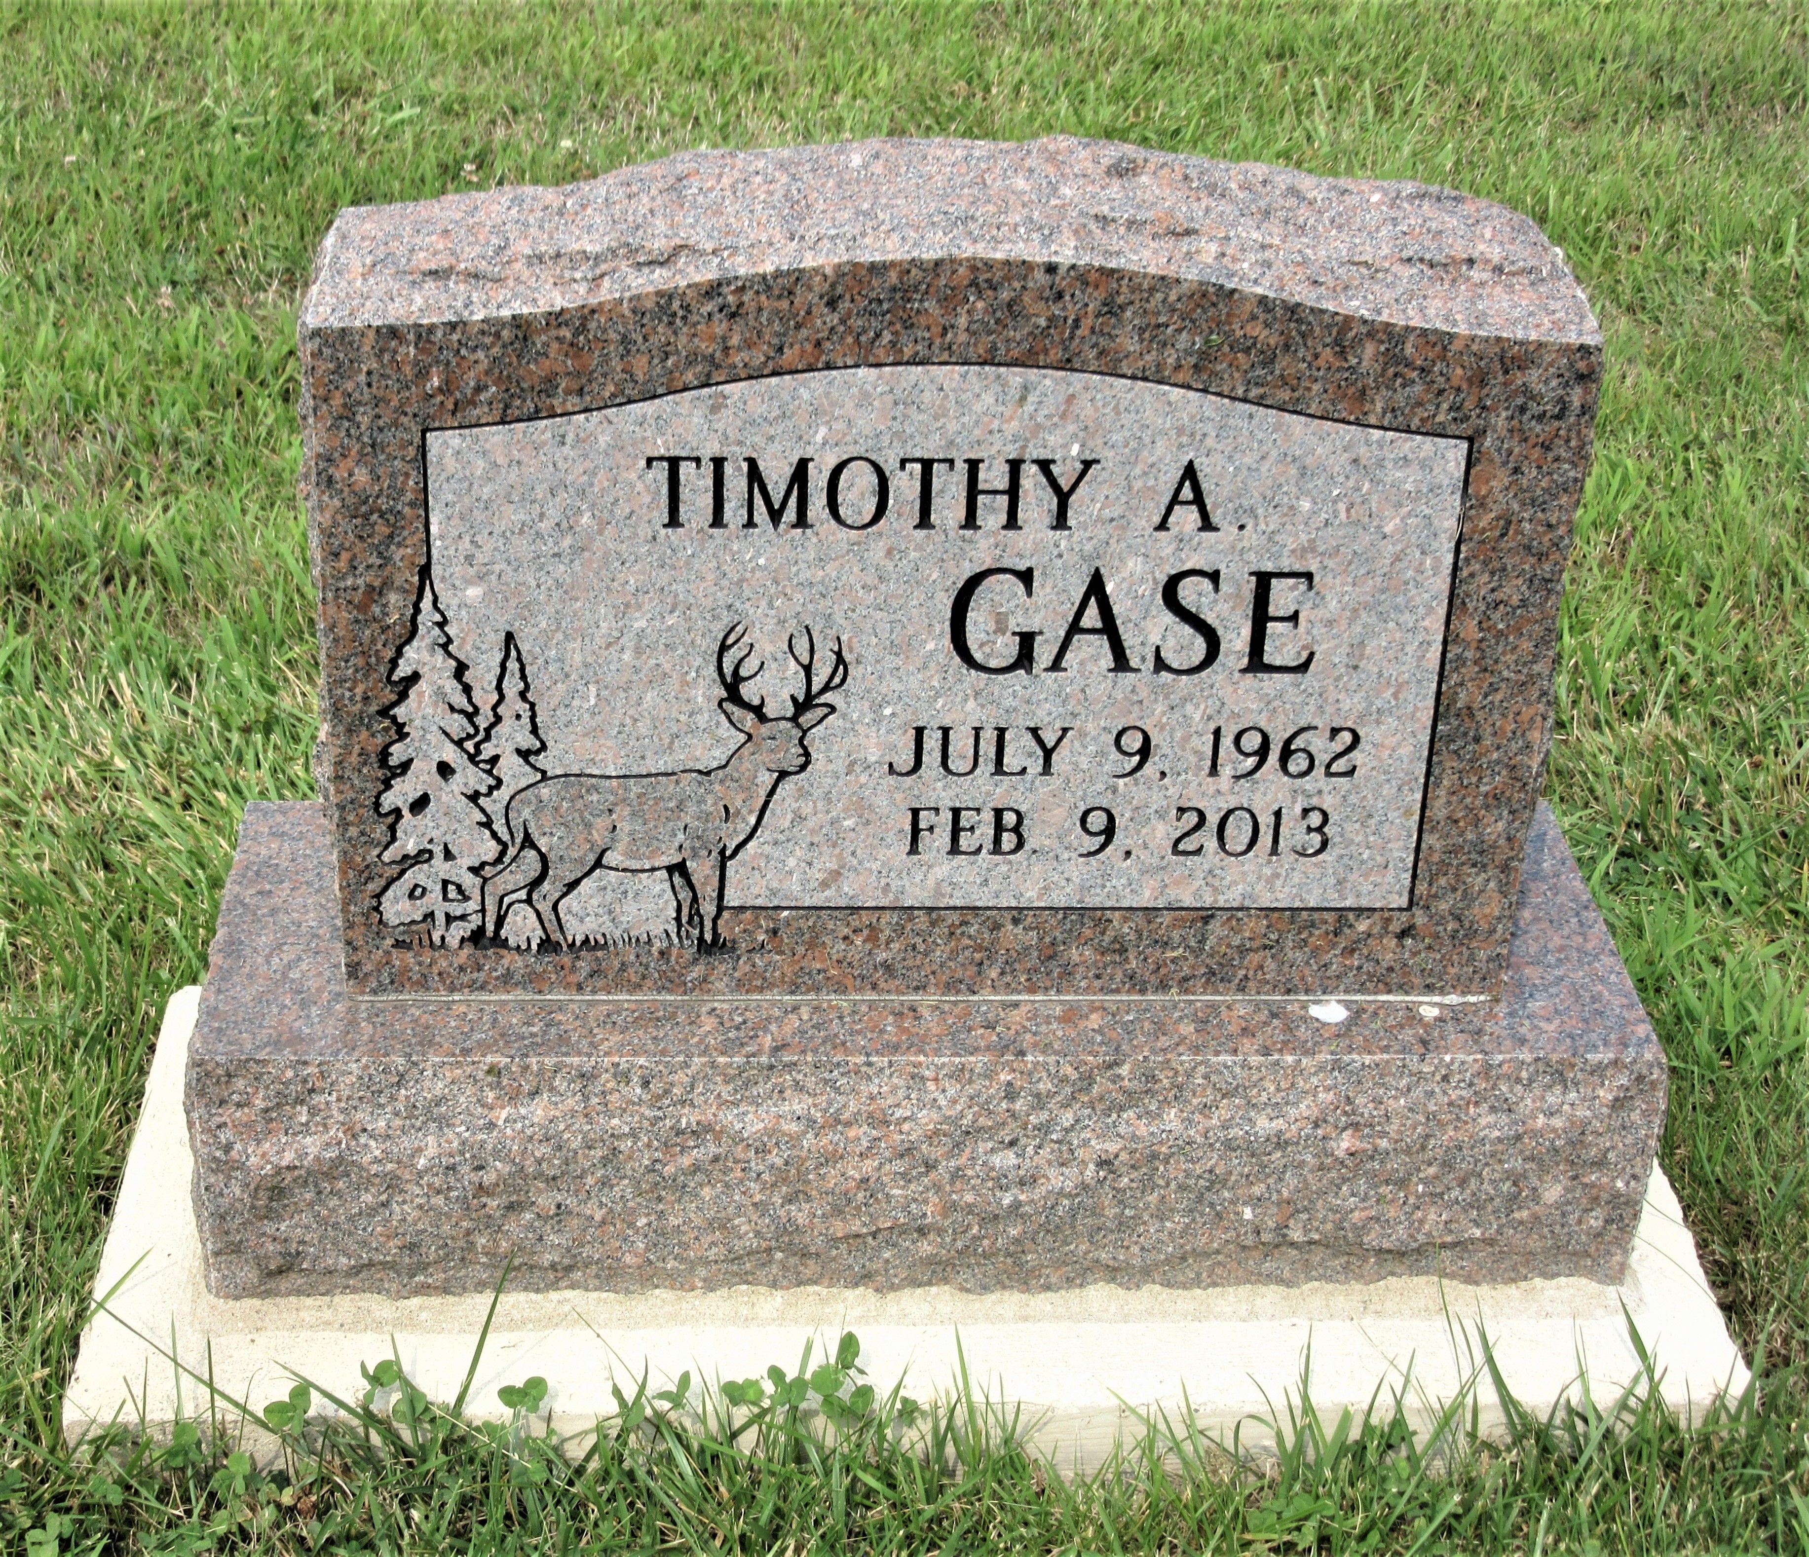
Photo by PLS

Timothy A. Gase, 50, of Decatur, IN died at his residence on Saturday, February 9, 2013. Tim was born on July 9, 1962 in Decatur, IN to Donald L. and Carol J. (Schuller) Gase.
Tim was a member of St. John the Baptist Catholic Church in New Haven. He was a member of the Eagles Lodge Decatur. He formerly worked for Gold Shield for 25 years, and then employed by R.M. Landscaping in Decatur. He was a 1981 graduate of Bellmont High School.
He is survived by his parents Donald L. and Carol J. Gase of Bluftton, IN; a son Travis P. Gase of New Haven, IN; a daughter Lyndsay M. Gase of Ft. Wayne, IN; 2 brothers Stephen L. (Mary) Gase of Bluffton, IN and Daniel L. Gase of Berne, IN; a sister Ann M. (Gase) Butler of Decatur, IN; 2 grandchildren Makenzie M. Gase of Woodburn and Tejae A. Gase of Ft. Wayne and his godchild Ashton M. Butler of Decatur.
Visitation will be from 4:00-8:00 p.m. Wednesday, February 13, 2013 at Haggard-Sefton & Hirschy Funeral Home. Calling also will be from 9:00-10:00 a.m. Thursday, Feb. 14th at St. Mary’s Parish Hall. A 10:00 a.m. Mass of Christian Burial will be on Thursday, February 14, 2013 at St. Mary of the Assumption Catholic Church in Decatur. Burial will be in St. Joseph Catholic Cemetery. Memorials are to the Family.

Haggard-Sefton & Hirschy Funeral Home
Adams County, Indiana
February 9, 2013

