Albert F. Hain
August 19, 1916 – December 30, 1939

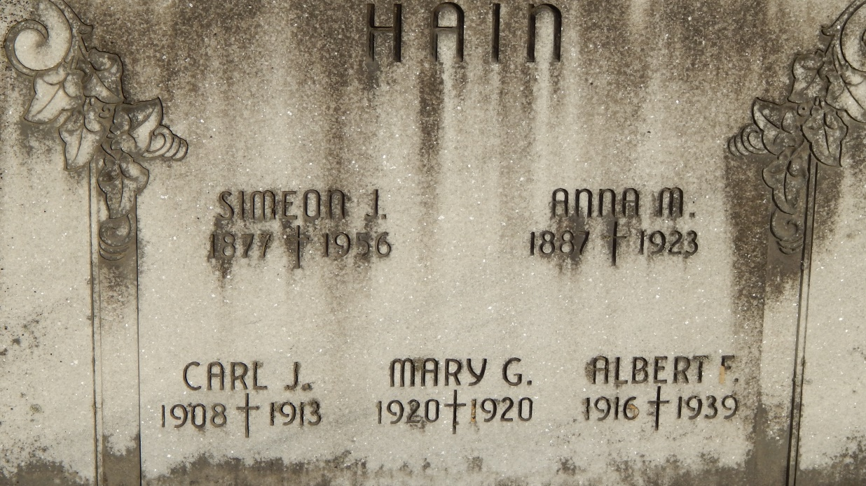
Photo by Alicia Kneuss

(Handwritten date: Monday, Jan. 1, 1940)

DEATH CLAIMS ALBERT F. HAIN
Popular Young Decatur Man Dies of Heart Trouble Saturday

Funeral services for Albert F. Hain, 23, popular Decatur young man and former star Decatur Catholic high school athlete, who died Saturday afternoon at 2 o'clock at his home, will be held Tuesday morning.
The services will be held at 9'clock in the St. Mary's Catholic church, of which he was a member, with the Rev. J. J. Seimetz officiating.
Burial will be in the St. Joseph cemetery.
Hain, known among his friends as "Johnny Boy," a nickname given him as a youngster when he first acted as a mascot for the Catholic high school basketball team, was born in Decatur, August 19, 1916, the son of Simeon and Anna Birtel-Hain.
He was graduated from Decatur Catholic high school in 1934. He played on the Commodore basketball team four years. After graduation he was employed at Lose's Restaurant, until illness forced him to quit. His congenial personality formed for him a large number of acquaintances.
About one year ago he first became acutely ill and was confined to his home. Treatment here and at Chicago failed to aid him. His death was attributed to myocardial insufficiency.
Surviving are the father, two sisters: Mrs. Richard Ryan, of Chicago, and Mrs. Cassius Keller of New Bedford, Massachusetts; three brothers, Bernard, Herman and Simeon, Jr., all at home.
The body was returned to the residence, 217 North Sixth street, Sunday afternoon from the Gillig & Doan funeral home and may be viewed there until time for the funeral service.

Adams County Historical Museum
1940 Feb-Dec Scrapbook, images 117 & 118
****

Decatur, Jan. 2 – Funeral services for Albert Hain, 23, former Decatur Catholic High School basketball star, who died of heart disease after one year’s illness at the home in this city Saturday afternoon, will be held Tuesday morning at 9 o’clock at the St. Mary’s Catholic Church in Decatur. Burial in the Catholic Cemetery here.
Survivors include the father, Simeon; two sisters and three brothers.
A lifelong resident of this city, he was a member of the Knights of Columbus, the Holy Name Society and the St. Mary’s Catholic Church.

Fort Wayne News-Sentinel (IN)
Tuesday, January 2, 1940

