Victor L. Hamrick
March 7, 1926 – May 18, 1996

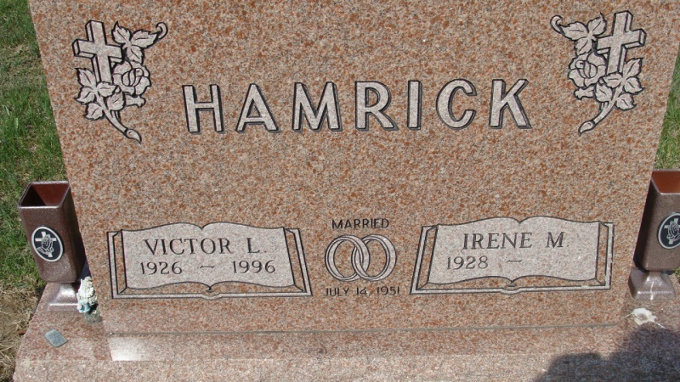
Photo by Alicia Kneuss

Victor L. Hamrick, 70, Decatur, died at 12:40 p.m. Saturday in Adams County Memorial Hospital after a long illness. He was born on March 7, 1926 in Berne, to Samuel L. and Nora V. Frank Hamrick and married Irene M. Heimann on July 14, 1951. She survives.
He retired in 1982 from International Harvester in Fort Wayne after a 36-year career. He served in the U.S. Navy in the Pacific Theater during World War II and was a member of St. Mary of the Assumption Catholic Church in Decatur and its Holy Name Society. He was a member of the Veterans of Foreign Wars Post 6236 in Decatur, American Legion Post 207 in Willshire, Ohio; Decatur Moose Lodge 1311; and the Pocohantas Lodge of the Improved Order of Redmen in Decatur.
Other survivors are a son, Roger Hamrick, Fort Wayne; four daughters, Mrs. Jerry D. (Colleen S.) Andrews, Mrs. Robert "Skeeter" (Annie M.) Braun, Mrs. Pat (Diane F.) Fullenkamp, and Mrs. Jim (Barbara C.) Gravens, all of Decatur; three brothers, Charles E. Hamrick, Decatur; Paul R. Hamrick, Monroe; Duane J. Hamrick, Rockford, Ohio; three sisters, Mrs. Robert D. (Evelyn F.) Luginbill, Decatur; Mrs. Lyndy (Norma L.) Lybarger, North Manchester; and Mrs. Tom (Carolyn J.) Baker, Chattanooga, Ohio; and nine grandchildren.
A prayer service will be held at 10 a.m. Tuesday in Zwick Sefton and Jahn Funeral Home, Decatur, followed by a Mass of Christian Burial in St. Mary's of the Assumption Catholic Church. Burial will be in St. Joseph Catholic Cemetery, Decatur, with military graveside services by the Willshire American Legion post and the Decatur VFW Post.
Visiting hours are unitl 5 p.m and 7-9 p.m. today, with a scriptural wake service there at 4:30 p.m. Preferred memorials are to Adams County Home Health Care or St. Joseph Catholic School in Decatur.
The obituary notice for Victor L. Hamrick which appeared in Monday's edition of the Democrat inadvertantly did not list one of the surviving brothers, Charles L. Hamrick of Willshire, Ohio. We apologize for the error and any inconvenience it may have caused.

Decatur Daily Democrat, Adams County, Indiana
Monday, May 20, 1996

