Jessica M. (Rambo) Hebble
September 25, 1974 – October 14, 2017

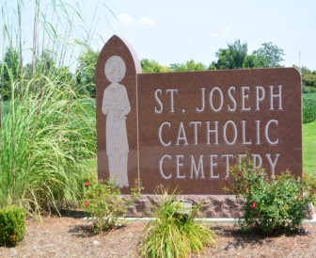
Jessica M. Hebble, 43, of Decatur, IN, passed away on Saturday, October 14, 2017 at Adams Memorial Hospital. She was born on September 25, 1974, in Ft. Wayne, IN, the daughter of Holly M. (Hebble) and Jeffrey Rambo. She was a member of St. Mary of the Assumption Catholic Church and worked as a homemaker.
Jessica is survived by her 2 sons, JeMarcus D. Hebble and Jayden J. Hebble both of Decatur; parents, Jeffrey & Holly Rambo of Decatur; a brother, Timothy (Lisa) Hebble of Decatur; 2 sisters, June Nicole (Kevin) Rambo-Torwele of Ft. Wayne and Veronica H. Rambo of Decatur; paternal grandparents, Richard & Marcella “Sally” Rambo of Decatur; loving aunts and uncles, Iris Urick, Laurie Buckingham, Heather Hebble, Terri Hebble, Rick & Jenny Rambo, Steve & Brenda Rambo, Scott & Karla Marbach; cousins, several friends, extended family, and also her bingo buddies.
She was preceded in death by her maternal grandparents, Vernon B. “Speck” & Lois Hebble Sr., uncles, Vernon B. “Ben” Hebble Jr., Larry D. Urick Sr., and Ronald Voirol; and a cousin, Larry D. Urick Jr.
A Funeral Liturgy will be held at 7:00 p.m. on Wednesday, October 18, 2017 at Haggard-Sefton & Hirschy Funeral Home, with visitation 2 hours prior from 5:00 – 7:00 p.m. Officiating will be Fr. Jose Fr. Jose Panamattathil, V.C and burial will take place in St. Joseph Catholic Cemetery at a later date. A Celebration of Jessica’s Life will be hosted by her family in the near future.
Memorials may be made to her sons’ education fund or Breast Cancer Awareness.

Haggard-Sefton & Hirschy Funeral Home
Adams County, Indiana
October 15, 2017

