Charles F. Keller
November 21, 1899 – July 9, 1971

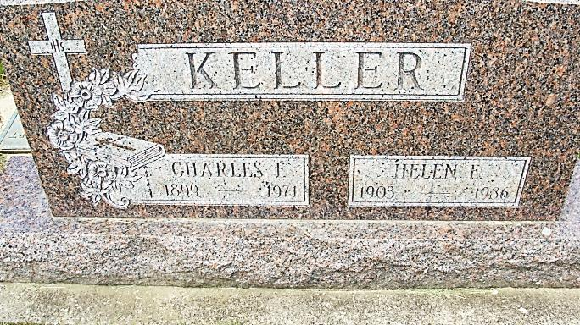
Photo by Alicia Kneuss

Jake Keller is taken by death

Charles F. (Jake ) Keller, 71, of Homestead N. 2, lifelong resident of the community, and retired General Electric Co. foreman, died at 3:15 p.m. Friday at the Adams county memorial hospital following a short illness.
Born in Adams county Nov. 21, 1899, he was a son of John and Nanny Frank-Keller, and was married to Helen R. Blee June 26, 1924.
Mr. Keller retired in 1963 after 43 years at the Decatur G.E. plant, where he served as foreman in the small motors department. He was a member of St. Mary’s Catholic church, the Holy Name society, and the General Electric Quarter Century club.
Surviving are his wife; three daughters, Mrs. Anthony (Mary Catherine) Teeple, Mrs. Joseph (Eileen) Wolpert and Mrs. Donald (Eloise) Roeder, all of Decatur; one sister, Mrs. Leone Johnson of Decatur; two brothers, Bernard (Bun) Keller of Decatur, and Floyd Keller of Rockford, O.; 11 grandchildren and two great-grandchildren.
Funeral services will be conducted at 10 a.m. Monday at St. Mary’s Catholic church, with the Rt. Rev. Msgr. Simeon Schmitt officiating. Burial will be in the Catholic cemetery. Friends may call at the Gillig-Doan & Sefton funeral home after 7 p.m. today until time of the services. The rosary will be recited at 8 p.m. Sunday.

Adams County Library, Decatur, IN
Obit Book F, image 57
Dated July 10, 1971

