Lorena L. (Reppert) Keller
March 21, 1911 – June 12, 1964

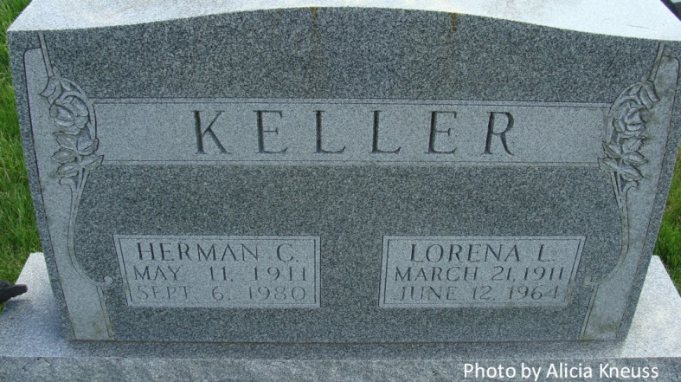

Mrs. Herman Keller Is Taken By Death

Mrs. Lorena Keller, 53, wife of Herman C. Keller, and well known Decatur resident, died Friday at her home, 453 Bollman street. Time of her death was fixed at approximately 9 a.m. by Elmer Winteregg, Jr., Adams county coroner. Death was believed due to an overdose of sleeping tablets.
Mrs. Keller, a lifelong resident of Adams county, was employed for 28 years in the finishing section of the Decatur plant of the General Electric Co. until retiring because of poor health.
She was born in Adams county March 21, 1911, a daughter of William and Emma Yost-Reppert, and was married to Herman C. Keller Sept. 2, 1944. She graduated from the Decatur high school in 1929. Mrs. Keller was a member of St. Mary’s Catholic church, the Rosary society and the Delta Theta Tau sorority.
Surviving are her husband; five sisters, Mrs. Forest (Ada) Owens and Mrs. Paul (Martha) Uhrick, both of Decatur; Mrs. Luther (Lela) Brokaw of Monroe, Mrs. Wallace (Clara) Miner of DeKalb, Ill., and Mrs. William (Violet) Sanders of Chattanooga, Tenn.; a stepsister, Mrs. Arlie (Gladys) Fisher of Fort Wayne, and three stepbrothers, Alton Corson of Decatur, and Harold and Dallas Corson, both of Fort Wayne.
Funeral services will be conducted at 9:30 a.m. Monday at the St. Mary’s Catholic church, with the Rt. Rev. Msgr. Simeon Schmitt officiating. Burial will be in the Catholic cemetery. The body was removed to the Zwick funeral home, where friends may call after 7 p.m. today until time of the services. The rosary will be recited at 8 p.m. Sunday. (Sat. June 13, 1964)

Berne (IN) Library Heritage Room
1962-1964 Adams County Obits
Dated Saturday, June 13, 1964

