Clarence W. “Willie” May
October 11, 1940 – December 9, 1978

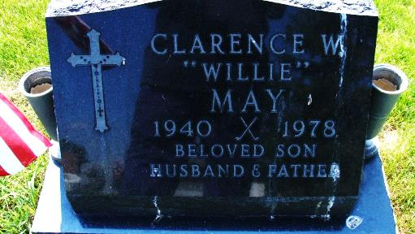
Photo by Alicia Kneuss

Clarence W. (Willie) May of 416 South 1st St., Decatur, 38, died Saturday at 3:55 a.m. due to smoke inhalation. May was dead on arrival at the Adams County Memorial Hospital.
He had resided in Adams County since 1950 and worked as a railroad conductor for Conrail. He attended the St. Mary’s Catholic Church and was a member of the Elks Lodge, the Moose Lodge and the American Legion.
Born on October 11, 1940, in Celina, Ohio, he was the son of Paul P. and the former Almeda (Cummings) May, currently Mrs. Verl Snyder of Decatur. Both parents survive.
Other survivors include two sons, Steven and David May; one stepdaughter, Deanna Bovine; two stepsons, Jimmie and terry Hike; two half-brothers, Paul P. May, Jr., Rockford, Ohio and Thomas O. May, Mendon, Ohio; two sisters, Mrs. Benito (Geraldine) Olalde, Decatur and Mrs. Jack (Sandra) Chilcote, Decatur; and one half-sister, Mrs. Laurence (Paula) Michaels, Rockford, Ohio.
Services will be conducted at 10 am Tuesday in the St. Mary’s Catholic Church. Father John Gillig will officiate with burial following in the St. Joseph’s Catholic Cemetery.
Friends and relatives may call Tuesday. The Rosary will be recited this evening at 7:30.

From the Florence Gause Collection
December 11, 1978

