Herman B. Meyer
June 9, 1897 – December 22, 1971

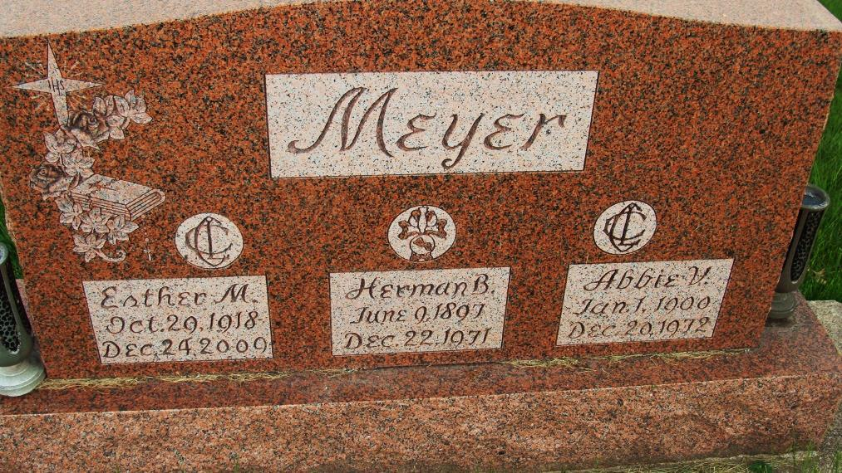
Photo by Alicia Kneuss

Herman (Hi) Meyer dies

Herman (Hi) Meyer, 74, 439 North Second street, owner of Hi’s Liquor Store on North 13th street from 1947 until its sale a few weeks ago, died at 8:05 p.m. Wednesday at the Adams county memorial hospital. He had been in critical condition since suffering a cerebral hemorrhage one week ago today.
Mr. Meyer, a lifelong resident of Adams county, owned and operated Riverview Gardens, near the river bridge on the Monmouth road, from 1933 until 1945. He opened a package liquor store on Court street that same year, and moved to the 13th street location in 1947. He and his wife operated the business until his retirement Oct. 27 of this year.
Born in Adams county June 9, 1897, he was a son of Bernard and Elizabeth Hessler-Meyer, and was married to Abbie Uleman Oct. 1, 1917. Mr. Meyer was a member of St. Mary’s Catholic church, the Holy Name society, Third Order of St. Francis, Fourth Degree, Knights of Columbus, the Elks lodge, and the Fraternal Order of Police.
Surviving in addition to his wife are three daughters, Miss Esther Meyer, Mrs. Robert (Norma) O’Shaughnessey, and Mrs. Charles (Florence) O’Shaughnessey, all of Decatur, one brother, Tony Meyer of Decatur; and five grandchildren. Five sisters and one brother are deceased.
Funeral services will be conducted at 10 a.m. Friday at St. Mary’s Catholic church, with the Rt. Rev. Msgr. Simeon Schmitt officiating. Burial will be in the Catholic cemetery. Friends may call at the Zwick funeral home after 6 p.m. today until time of the services. The Holy Name society will recite the rosary at 8 p.m. (Dec. 23, 1971)

Adams County Library, Decatur, IN
Obit Book F, image 77
Transcribed by Janice Vasilovski

