Aurelia (Roman) Morales
August 15, 1927 – September 9, 2017

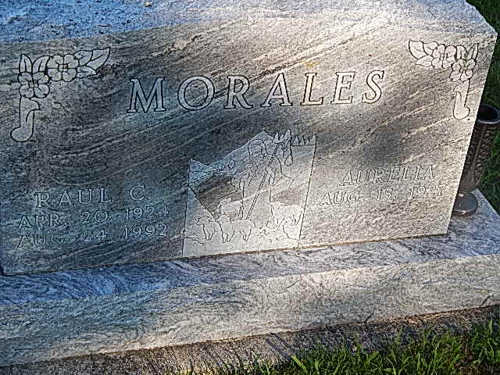
Photo by Alicia Kneuss

Aurelia R. Morales, 90, of Decatur, IN, passed away on Saturday, September 9, 2017, at Swiss Village. She was born on August 15, 1927, in Austin, Texas, the daughter of the late Mariano and Ernestina (Hernandez) Roman. On June 24, 1943, she married Raul C. Morales and after 49 years he preceded her in death on August 24, 1992.
She was a member of Living Word Temple. She worked as a lifelong homemaker and was also a greeter at Wal-Mart for 15 years.
Aurelia is survived by a son, Ricardo R. (Julie) Morales of Sarasota, FL; 3 daughters, Maria C. (Paul) Macias, Alicia (Servando) Martinez, and Gloria M. Morales all of Decatur; a brother, Ray (Carolyn) Roman of Decatur; 2 sisters, Benita Mata of Decatur and Emma (Ray) Macias of Ansonia, OH; 10 grandchildren, 21 great grandchildren, and 4 great-great grandchildren.
She was preceded in death by a son, Raul Morales Jr., 2 brothers, Ruben and Reynaldo Roman and 2 sisters, Maria Ortiz and Manuela DeLeon.
Visitation will be on Friday, September 15, 2017 from 4:00 – 8:00 p.m. at Haggard-Sefton & Hirschy Funeral Home.
A Funeral Service will be held at 10:00 a.m. on Saturday, September 16, 2017 at Haggard-Sefton & Hirschy Funeral Home, with calling 1 hour prior to the service from 9:00 – 10:00 a.m. Officiating will be Pastor Daniel Aguilar and burial will take place in St. Joseph Catholic Cemetery.
Memorials may be made to the Living Word Temple.

Haggard-Sefton & Hirschy Funeral Home online obit (accessed 09/10/2017)

