Anthony F. Murphy
September 10, 1911 – April 25, 1971

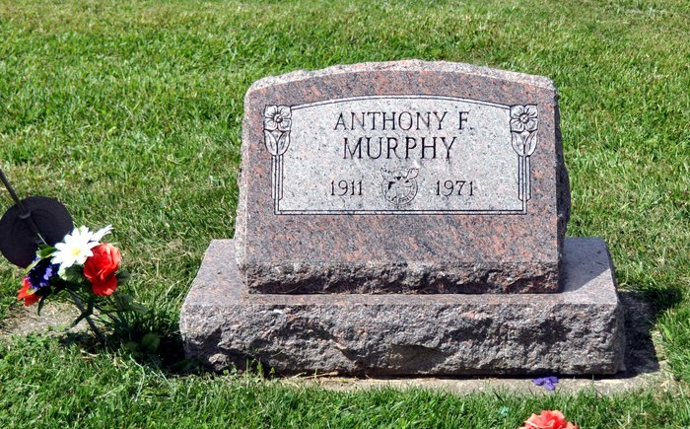
Photo by Deb Curry

Anthony Murphy dies on Sunday

Anthony F. Murphy, 59, of 618 N. Third St., died at 3:55 p.m. Sunday at the Adams county memorial hospital following an extended illness. He was employed by the Decatur General Electric plant.
He was a member of ST. Mary’s Catholic church, Holy Name Society, Loyal Order of the Moose (past governor), Legion of the Moose, Pilgrim Decree of the Moose, Elks’ Lodge, American Legion, V.F.W., and G.E. Quarter Century Club and a veteran of World War II.
He was born in Decatur on September 10, 1911, the son of James E. and Catherine A Lang-Murphy, and was never married.
Surviving are four brothers, Joseph Murphy and James W. Murphy, both of Decatur, Edward Murphy, Piqua, O., and Pat Murphy, Geneva.
Funeral services will be conducted at 10 a.m. Wednesday at the St. Mary’s Catholic church, with Msgr. Simeon Schmitt officiating. Burial will be in the St. Joseph cemetery. Friends may call at the Winteregg-Linn funeral home after 7 p.m. today. Moose services will be held at 7 p.m. Tuesday. The Rosary will be recited at 8 p.m. Tuesday. Military graveside rites by the American Legion and the V.F.W.
[rest is missing] (April 26, 1971)

Adams County Library, Decatur, IN Obit Book F, image 51
Transcribed by Janice Vasilovski

